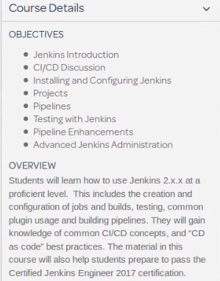

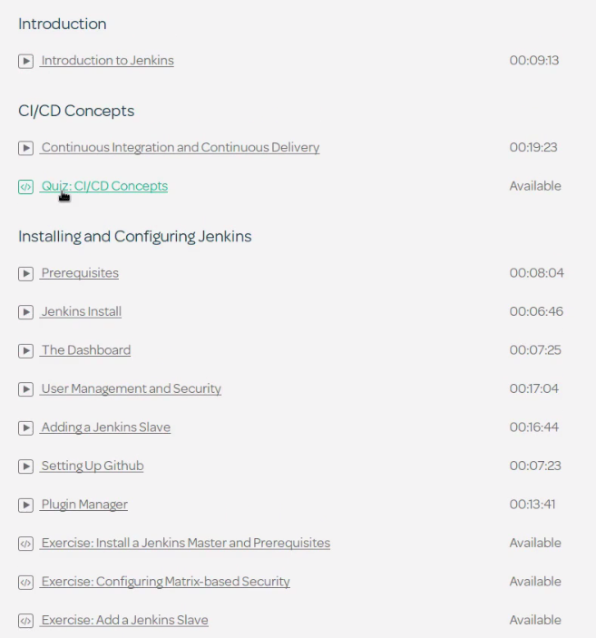

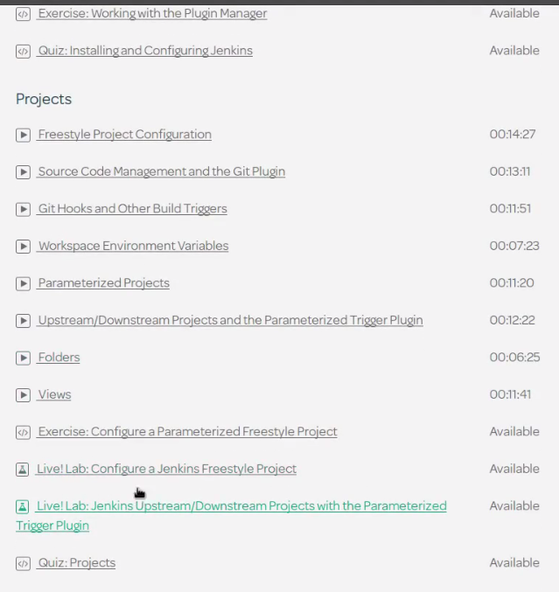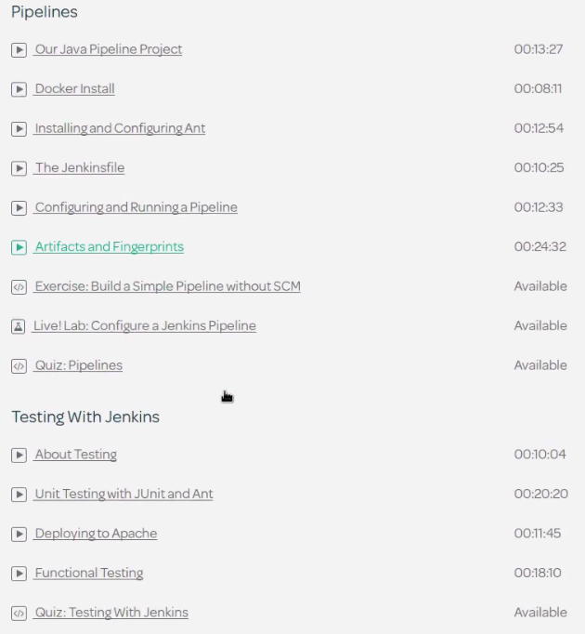

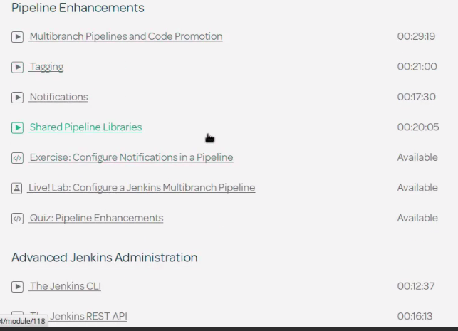

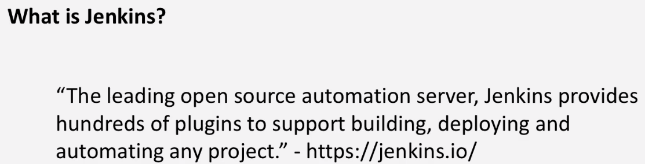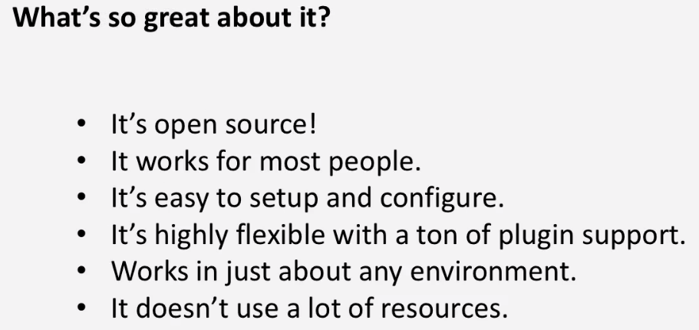

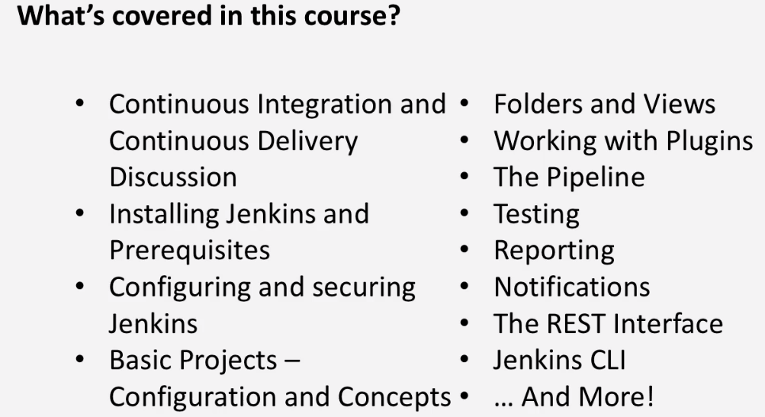

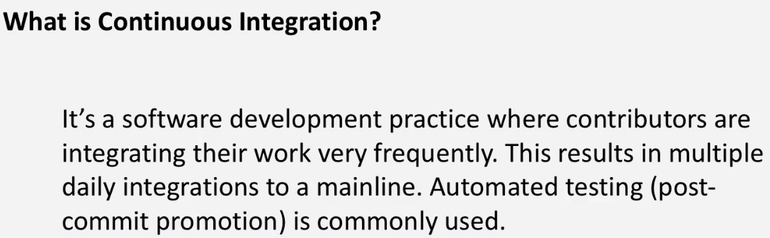

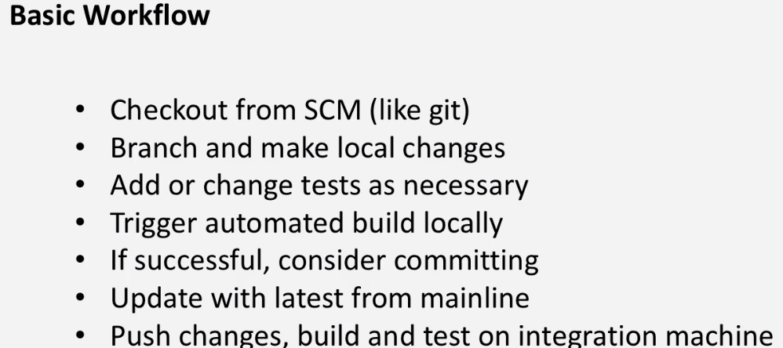

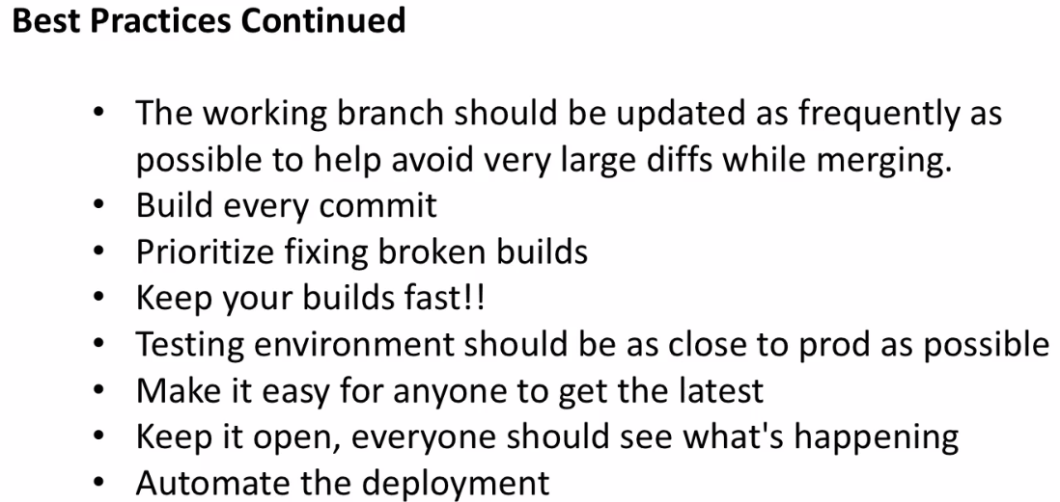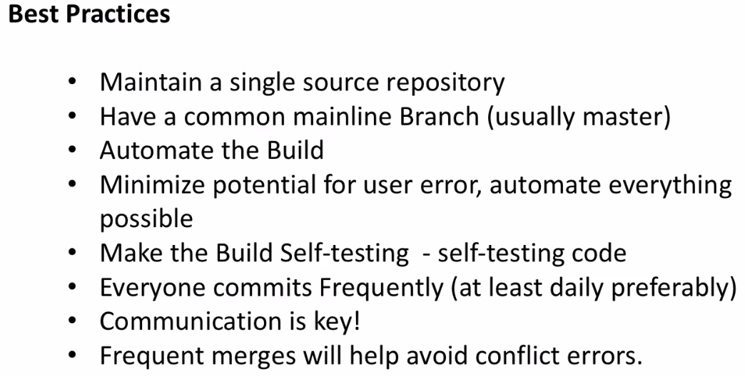

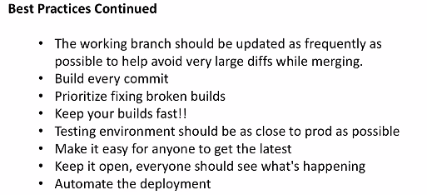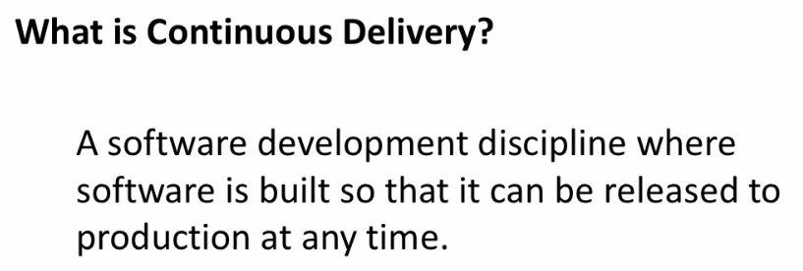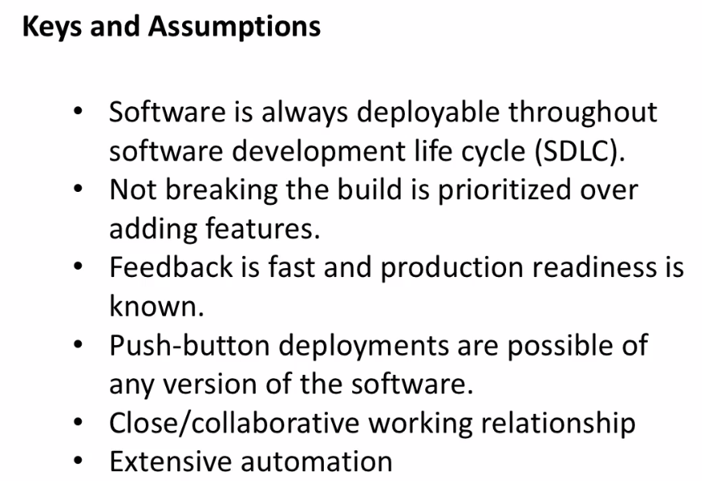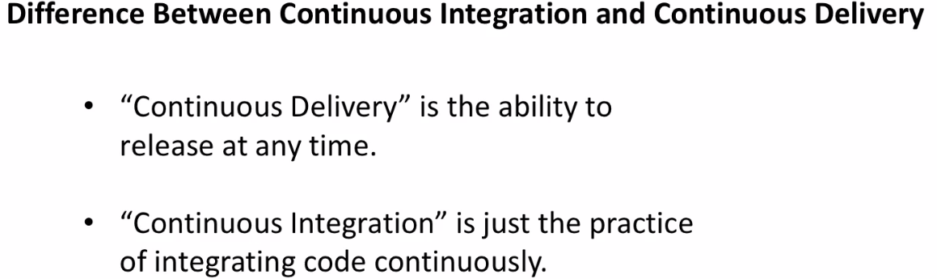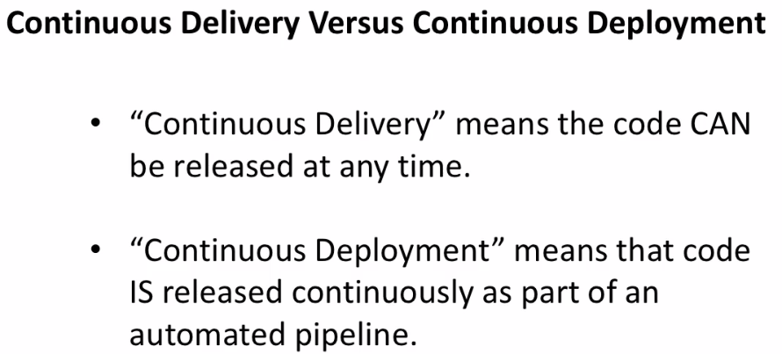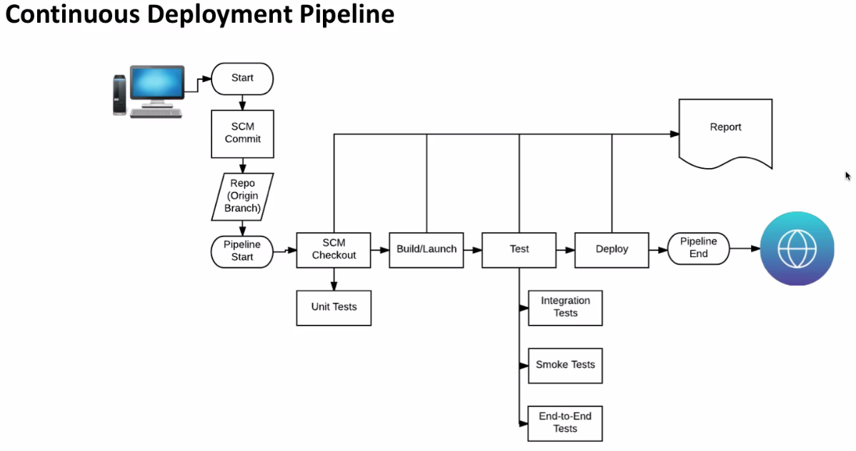

**PREREQUIESTIES**

1. **Which java**

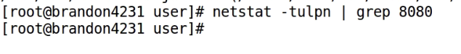

3.)

Yum list java* -🡪 default repos lists java

**4.) Download java 64 bit**

**Rpm –Uvh java**

**6.) Which java**

**If we have multiple versions of java running--Note: plz check how to setup global, local java variables..**

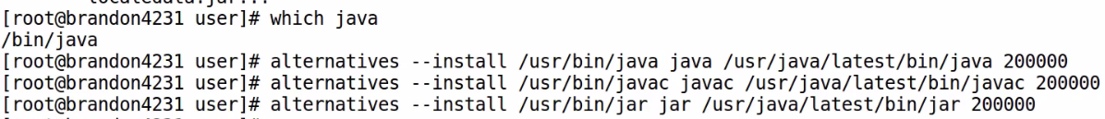

**7.) Set environment**

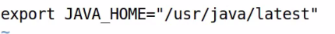

***---------------------------------------_---------------------------------------------------------------------------------------_--------***

**Jenkins Install**

1. **Add yum source for Jenkins repository**

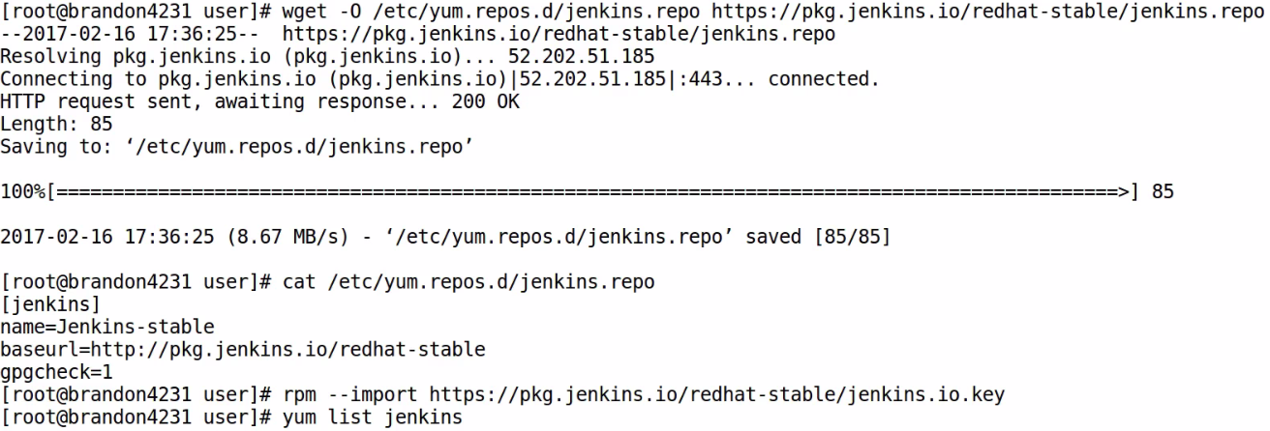

1. Import Sign in key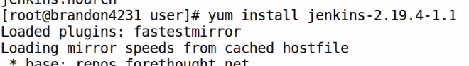

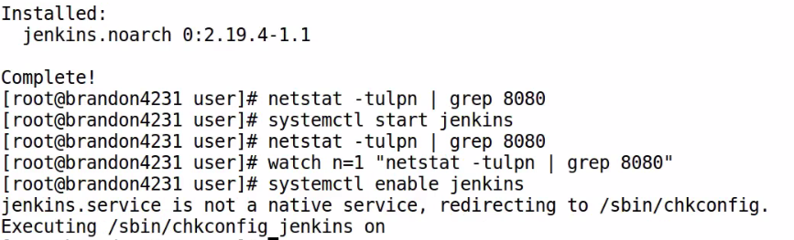

1. Disable repo after Jenkins installed



5.)

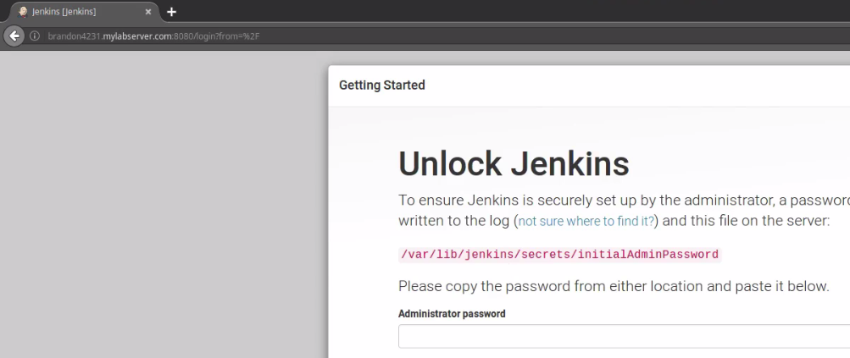

6.)

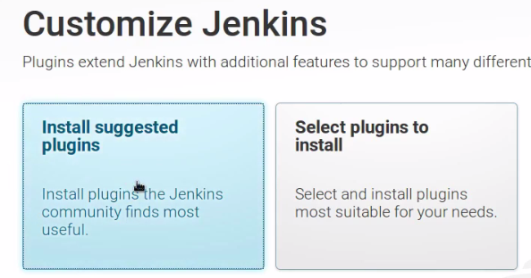

7.)

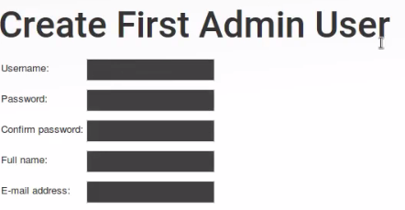

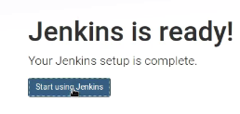options

Dashboard

**---------------------------------------_---------------------------------------------------------------------------------------_--------**

**1.)search**

Search: Jobs, projects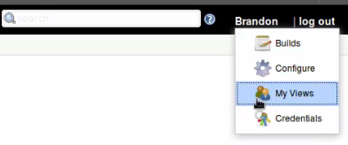

Logout

My views: build, configure, View, Credential

Enable auto refresh🡪 when lot of multiple jobs running or when waiting for job to finish

**2.)New item =**🡺 **where you add projects, pipelines**

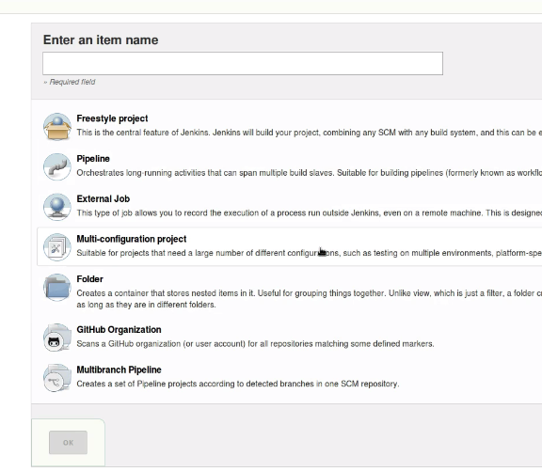

1. People option🡪 below New item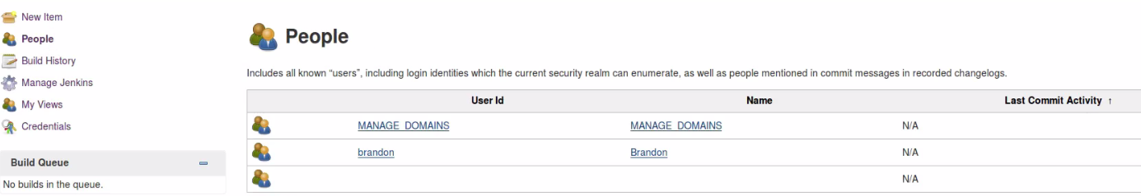
2. Over view of build history of all projects.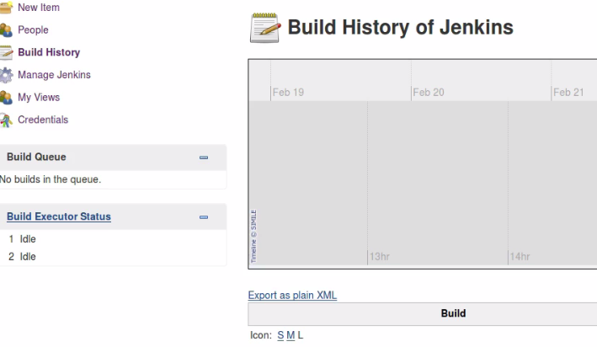
3. Manage Jenkins

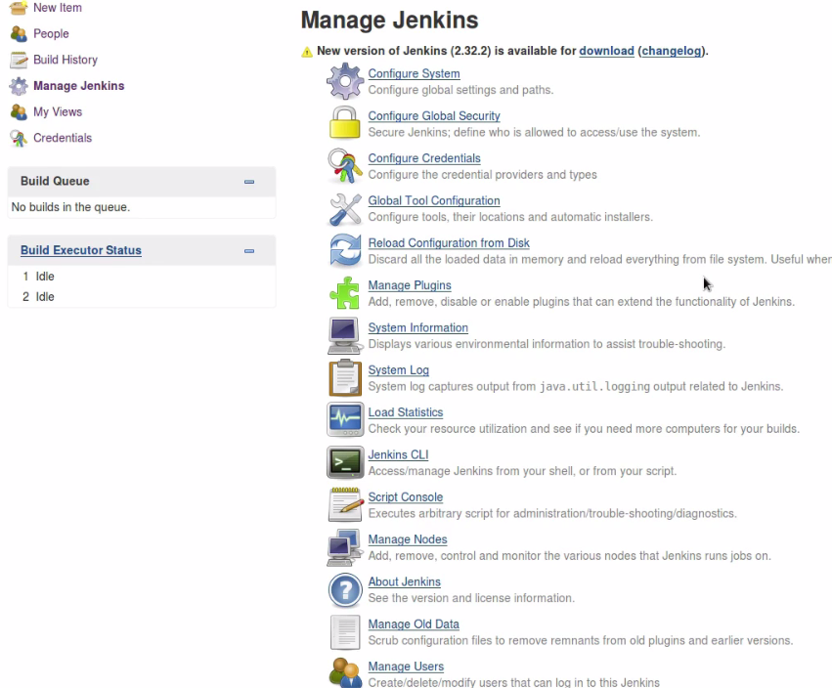

1. My views: For configuring views for your project results.. It’s customizable views

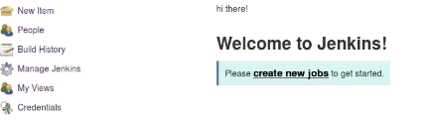

1. Credentials

List out credentials you have …for Jenkins, users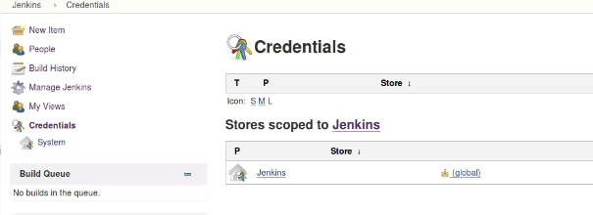

8.) Build executor: Runs projects/jobs that are executed by Jenkins, and can run parallel.

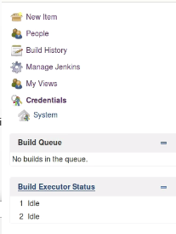

If u have 2 executors/ 2 jobs running at same time, Default no .of executors on master is 2.

If jobs are occupied, u can see jobs waiting to be run on Build queue.If more than 1 or more than no.of executors available,anything that is waiting to run..

1. Date when page is loaded



Rest API

Jenkins version -2.19.4

**---------------------------------------_---------------------------------------------------------------------------------------_--------User Management and Security**

1. **Setup authorization for admin user**

Manage Jenkins-> Configure Global security

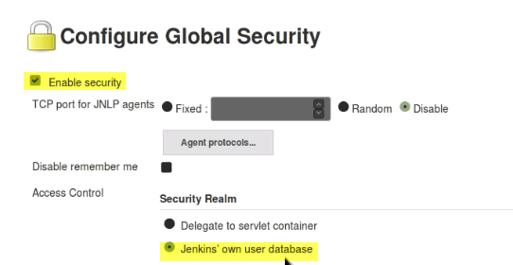

These options are enabled by default.., and also..Anyone can do anything.

a.)

b.)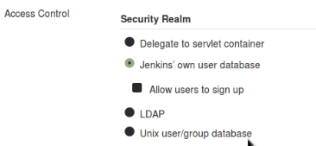

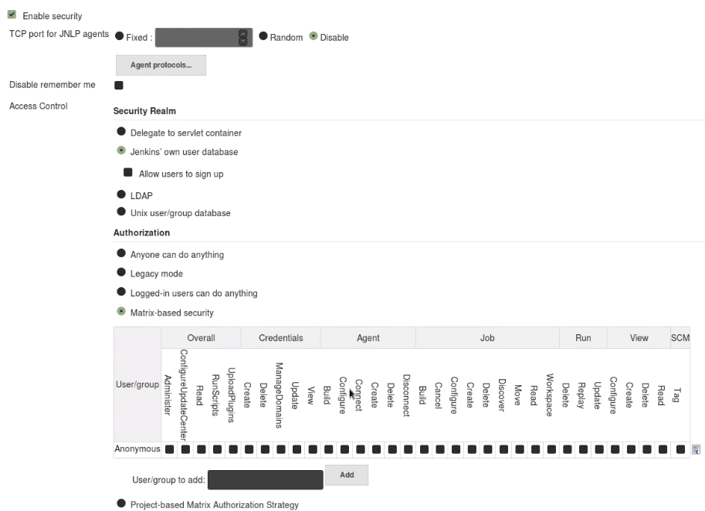

c.) Select Matrix based security

It allows to grant specific information to users and groups.

It divided to standard categories:

Overall: In Context of Jenkins as a whole.

Credentials:

Agent/Slave

Jobs/Projects

Running Projects/job

View

SCM

These categories, we need to administer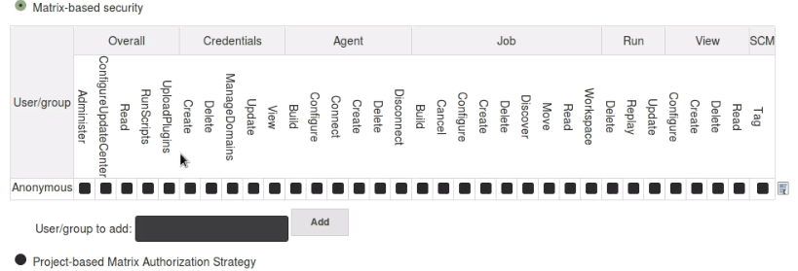

1. **Overall:**

**Administer**: Any sensitive, full system access

**Configure Update Center:** Proxy configure, updates.

Read:



Run scripts:

Upload plugins:

b.)**Credentials** Create: 



Delete:



Manage Domains:



Update:



View:



**C.)Agent/node ----Jenkins admins duty to manage slave**

Build: build with particular slave with this user.

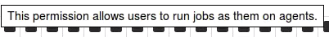

Configure:

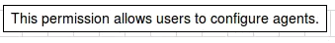

Connect:



Create:

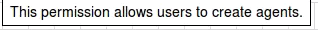

Delete/Disconnect:

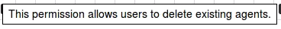

**d.) Jobs/projects**

Build:

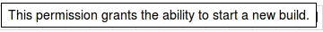

Create:

Delete: 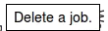

Configure: 

Cancel:

**Discover (interesting): If user is unauthorized a page or isn’t there. It will take you to login page**

**Move/organize job:** 

**Read:**

**Workspace: When we trigger build, project will take workspace and do all necessary actions.**

**Particular user who have access to workspace**



**e.) Run:** Little bit more specific than Job—Configure, Update, Display, Delete

Build: Build 3013 or particular project

Delete build

Replay/Update particular build.



Update: Update a particular Build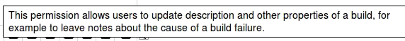

**f.) View (ability to custom/have a dashboard): Configure,create,Read, delete**



**Create:** 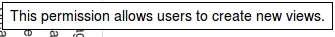

**Delete:**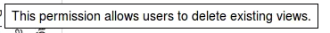

**g.)SCM : user have permission to tag project**

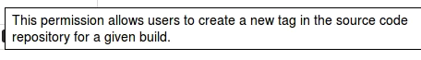

**Add users:**

**Manage Jenkins-> Manage Users**

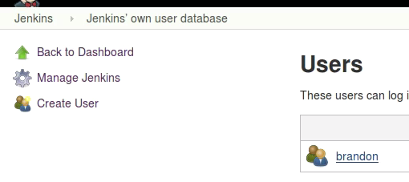

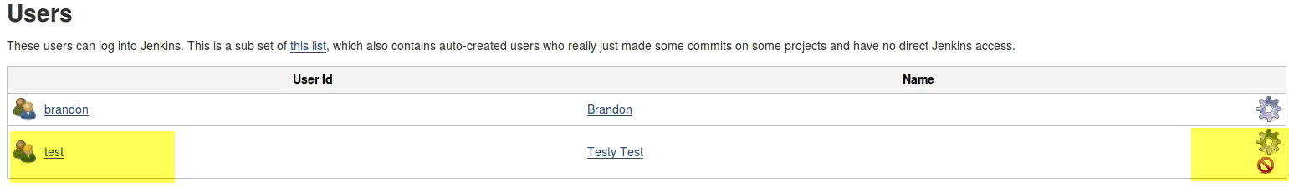

**Configure🡪 Give Overview of User**

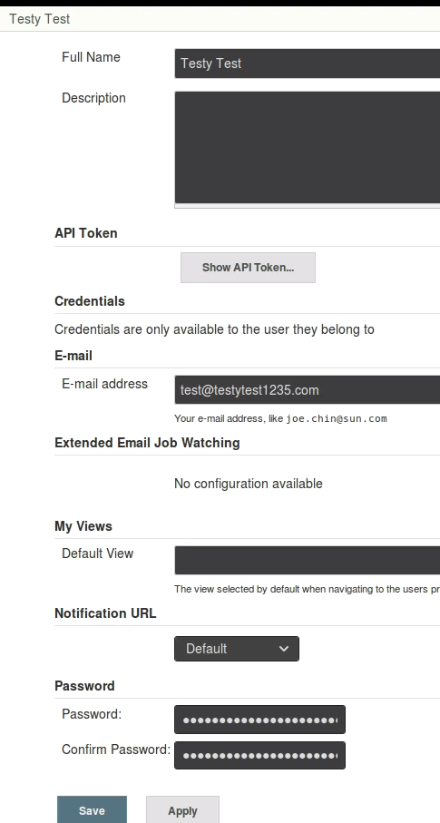

* **Set views available to user.. Default views**
* **Forget password: can do here.**
* **Git SSH keys.., we can add them here**
* **API tokens …REST API access**

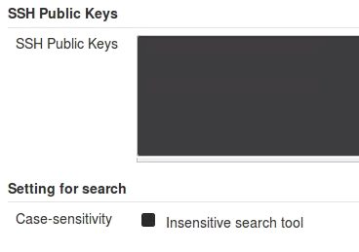

**Add user –Role based**

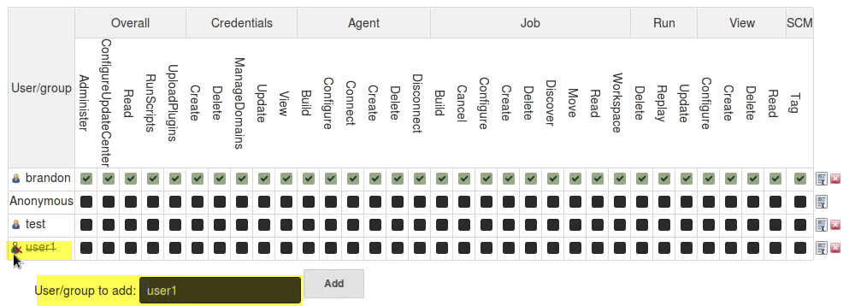

**Reasonable permissions for developer:**



**Fewer options available for test user:**

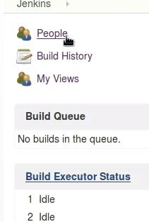

**---------------------------_________________--------------------------------------------________________________**

**Adding a Jenkins Slave (distributed setup)**

**Projects need to be configure in Jenkins is extensive..**

**As we try to scale up.. we use memory, CPU being over utilized. Performance is low.**

**By distributed, we can reduce load from master.., and limit load.**

**A slave /node/agent: A machine setup that offloads load from master, and once setup distribution of jobs automatically.**

**Adding slaves doesn’t actually change interactive with jenkins overall.**

**All admin tasks, http requests.., executors can still actually exists on master.**

**So even if u have slaves, you can run jobs on master as well.**

**Delegation (**ప్రతినిధి బృందం) b/w master and slaves happens automatically.

Ex: I have 5 slaves.. If i have no prefernece to run on slave.Jobs gets distributed equally among slaves..However, if u have particular environment**.., u want to run on particaulr slave/node...Cant specify that.**

Ways to configure Slave:  
1.) Java plugin

1. Windows client for agents
2. SSH path

**On Master:**

1. **Generate SSH key for Jenkins user**

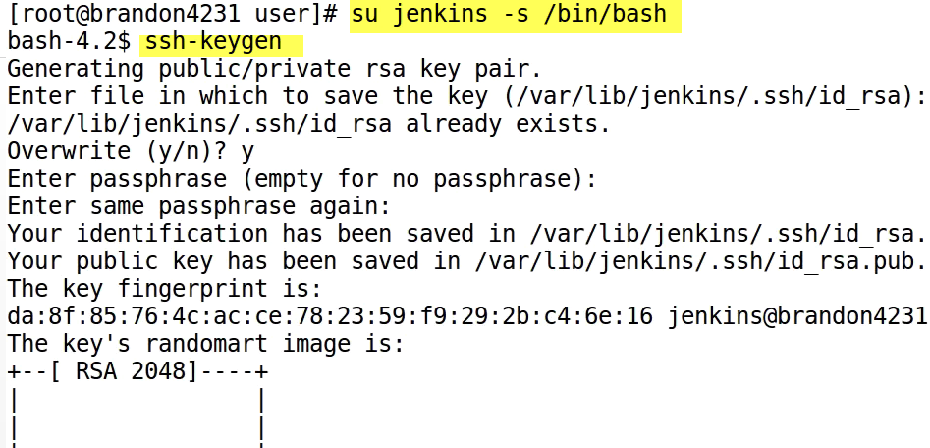

1. **View key generated**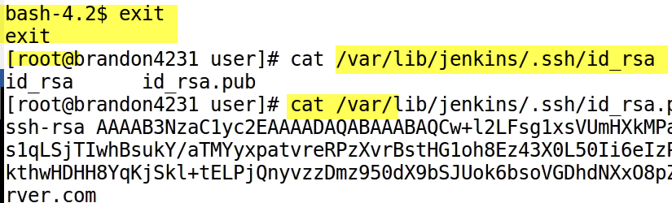
2. **Slave: On New tab, login/SSH to slave server**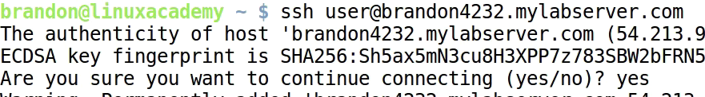
3. **Add user Jenkins**

**d-> Specifying home dir.**

**Permission denied, while creating jenkins user.**

**Login as root…a.) Create jenkins user b.) create .ssh directory**

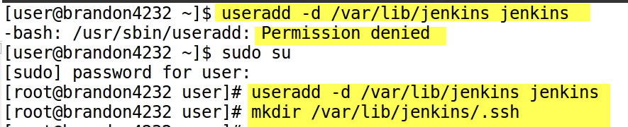

**c. Create authorized_keys file**



**Paste key.. that we generated on master.**

1. **Install java in slave node**

**SCP java rpm from master to slave**







**Set Environmental Varible:**



1. **Master:**

**Manage Jenkins🡪 Manage Nodes**

**Here we see only master. No Nodes**

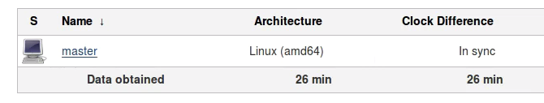

**Click on master:-🡪 It will show projects tied to master node.**

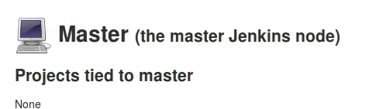

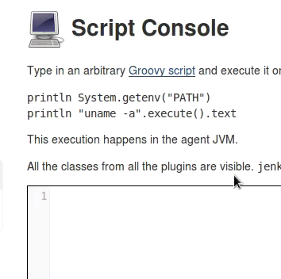

**Script Console:**

**Access to script console. To execute scripts from nodes**

1. **New Node (scape is Ok.) No special char. allowed**

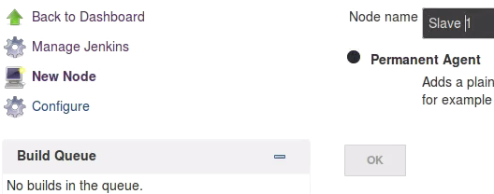

**No of executors:2 🡪 No. of builds that I can execute on slave at a time.**

**This is also Default mount on master as well.**

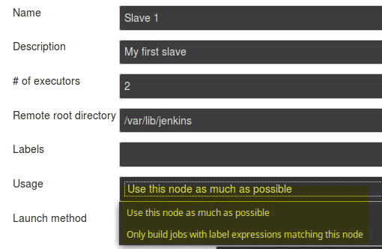

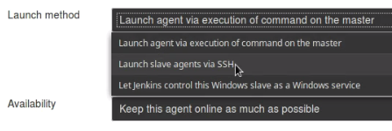

1. On Linux based—Go with SSH

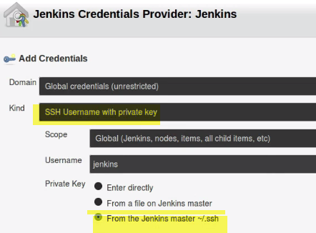

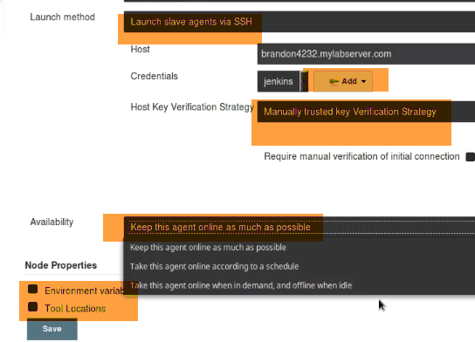

Issue: Click on node

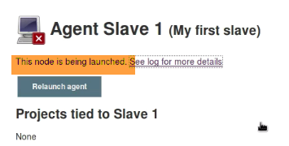

1. **Executing Job**

Create new job:

**General:**

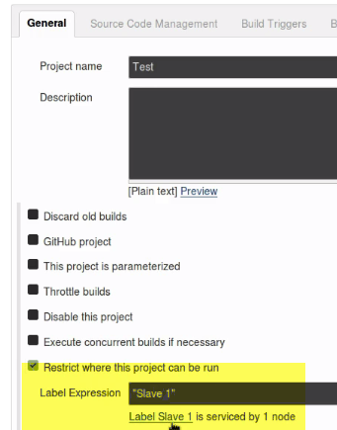

Where this job should run on.

**Build:**

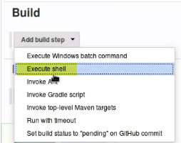

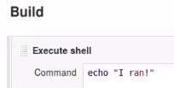

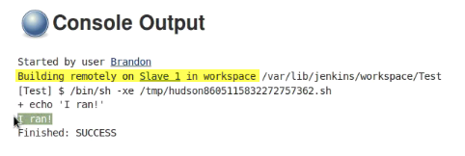

**-------------------------_---------------------------------------------_--------------------**

**Setting Up GitHub:**

For Jenkins user, we are gonna add SSH keys. So jenkins can actually act on our repos that we setup on github.

So, if we setup a job to listen to commits on github repo, it’s important to have that SSH key.

If we want jenkins to be able to add a tag, when we build something🡺 Some condition to met.

We need to add SSH key. It gives permission to build from git repos.

Jenkins master:

We need pub key of Jenins user of remote m/c.

Jenkins home: /var/lib/Jenkins

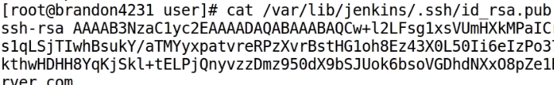

Copy Key and got to git hub

**Account🡪 settings🡪SSH and GPG Keys🡪 New SSH key**

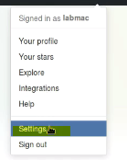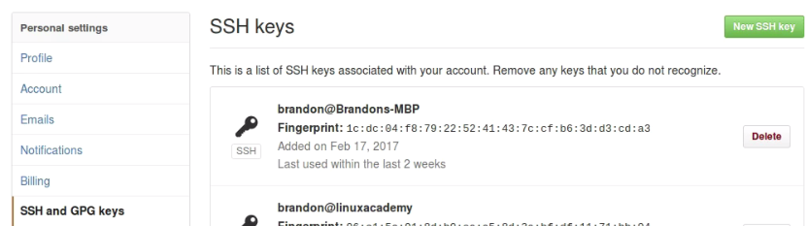

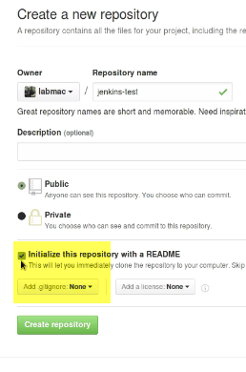

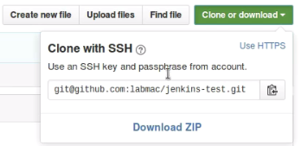

**We will need SSH from local environment also to github account.**

**------------------------------------------------_______________----------------------------------------**

**Plugin Manager**

Plugins can be added to Jenkins to add additional functionality.

Ex: Source code mgmt plugin ---github

**One limitation:** We can install only latest version initially, and also downgrade to one version.

Plugin manager: UI used to install /manage and configure plugins in Jenkins GUI.

Now, Installing, Downgrading, removing Plugins:

Installing: 1.) Plugin manager

2.) Advanced m/d to load hpi file from UI

HPI file contains code for plugin

3.) Jenkins CLI

1. **Install:** Manage Jenkins-> Manage Plugins🡪 Available



We can see here updates available.

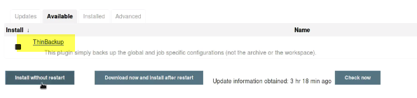

Thinbackup: Backup configuration jobs. It will not achieve/or do anything with your wks.

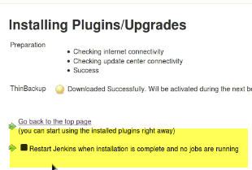

InOrder to Use plugin, we need to restart. Check Restart.

**If we have any jobs running, it will stop those jobs before initiating restart.**

1. **Uninstall:** Manage Jenkins-> Manage Plugins🡪 Installed

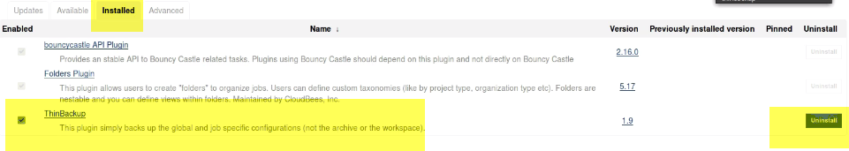

Click Uninstall ---Restart (otherwise it will show Uninstall Pending)



It will notify all users, and also prevent new jobs from starting.

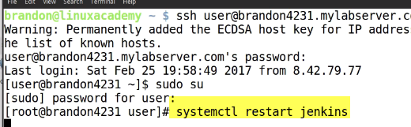

Login to Jenkins Master.., and restart

1. **Install Specific Version:** Manage Jenkins-> Manage Plugins🡪 Advanced->Upload Plugin



**Thinbackup-**--1.9 available on Plugin Manager.

**There is some issue with 1.**9, and want to install 1.8

**Click on ThinBackup**🡪 Achieves

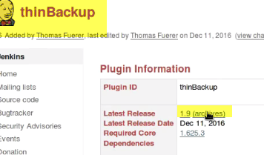

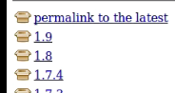



Manage Jenkins-> Manage Plugins🡪 Advanced

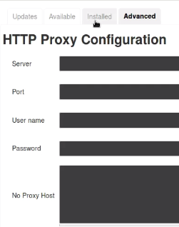

**No need to fill proxy info.**

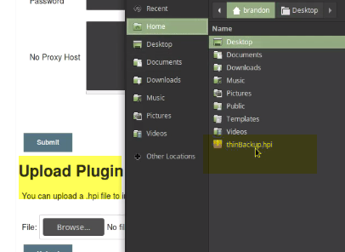

**Manage Jenkins-> ThinBackup**

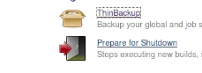

1. **Update Plugin** Manage Jenkins-> Manage Plugins🡪 Updates
2. **Downgrade**



**-----------------------------------_________________----------------------------------_____________**

**Our Java Pipeline Project:**

For this, we are gonna use java project.. Mainly bcz it fit well with Jenkins.

Jenkins written in java. Lot of tools/plugins like junit , coverage, ant fit well with java..

1. Create Java Project in github

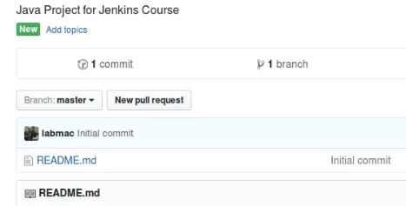

2.)

3.) Create Project structure

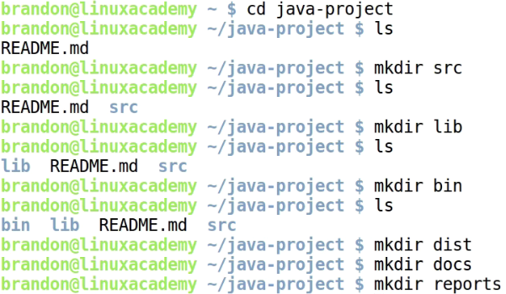

Src, lib(binary), bin(built binaries from src code), docs, dist(distributable binaries), reports.

So of these folder or dir populated during built.., don’t necessary need to keep track on git repo.

Vim **.gitignore**

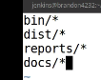

* Create 2 .java classes.
* Jenkinsfile---empty now
* See project structure

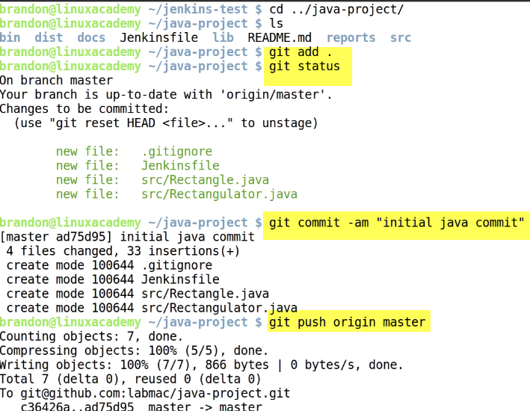

**Switch off master branch. Create new branch and push it**

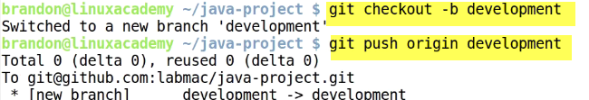

**-----------------------------------_________________----------------------------------_____________**

**Docker Install**

As we get into pipeline, configuration of Jenkins…, we will be using containerization docker.

So we need to get docker installed and configured in slave node.

1. **Login to remote(node)**



**4232-🡪Node; 4231 🡪master**

1. **Remove existing docker, package container selinux**



Selinux roles may Conflict with configuration we need for docker version.

1. Install yum utils bcz we are gonna use for yum configure mgmt. command..



1. **Add docker repo using yum config manager**



**We can see docker source in this repo file**

1. **Yum clean all🡪 clear cache**
2. **Install docker**



Ce🡪 community edition

Version->17.03 this is for enterprise Linux edition centos

Installtion done.

1. Now we need to add Jenkins user to Docker group



1. Start docker service



1. **Now, we have to login to Jenkins master and refresh service**

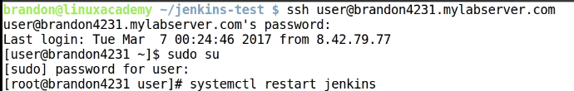

**4232-**🡪**Node; 4231** 🡪**master**

**Now that docker installed on slave.., and Jenkins refreshed**

1. **Login to Jenkins Url as admin user**

**Run hello world**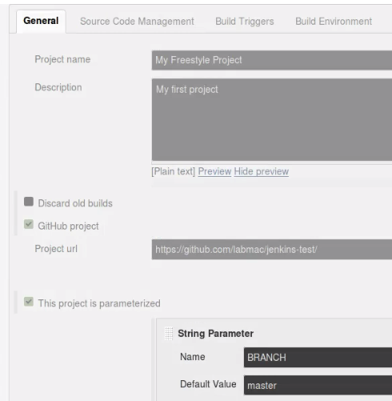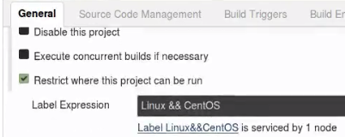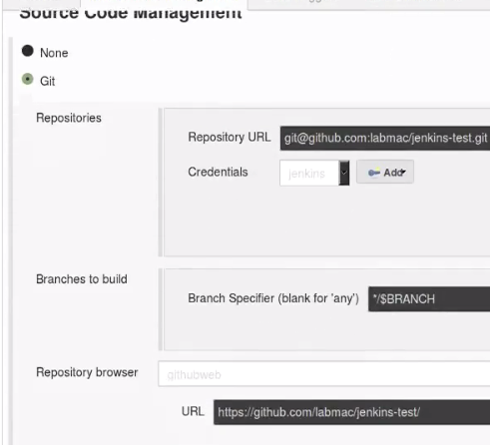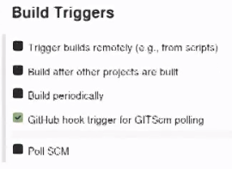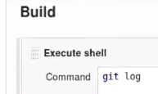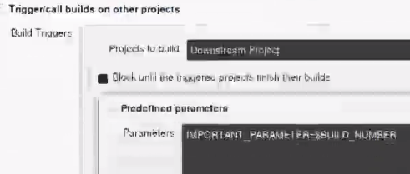

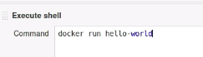

**This is standard way to run docker test.**

**It tells docker is running in expected way**

**-----------------------------------_________________----------------------------------_____________**

**Installing and Configuring Ant**

1. Get ant installed on master and slave node.

Master:



1. Pull download tar file from apache—ant installer
2. Unpack to opt



1. Symbolic lin dir we packed to opt



5.)Env



1. TO get ant running:





**6.**)Test



Now we are going to create a build file

Variables in Jenkins will be available in the Build file.., that helps in building file name s etc…

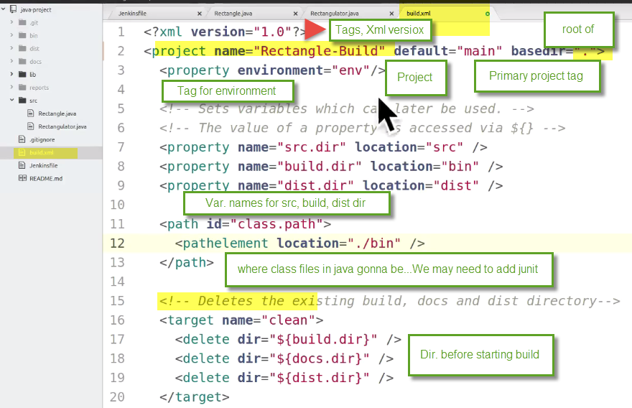

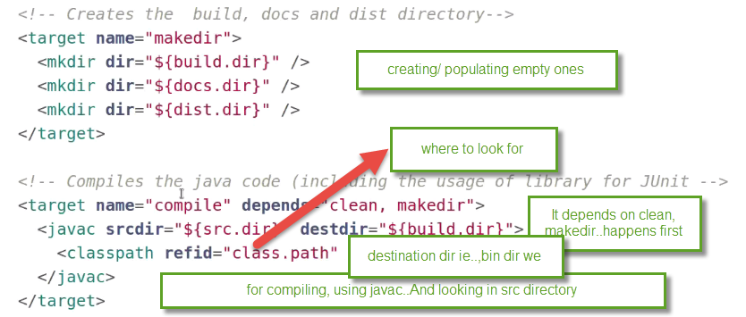

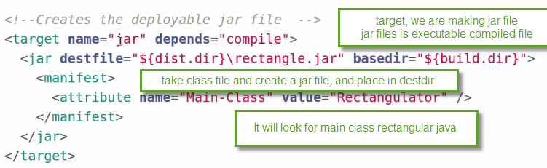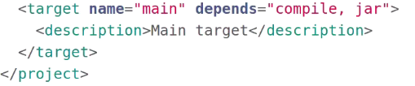

1. Commit it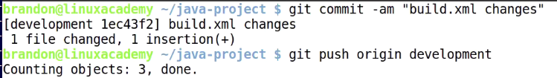
2. Login to master, and build.



**Manual:** Switch to Jenkins user, bcz its credentials for setup for github.

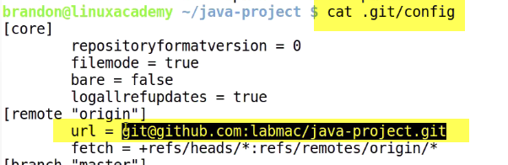

Build: ant –f file –v

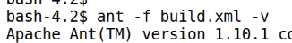

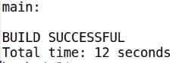

Now we have rectangle.jar file

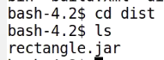

**Java –jar rectangle.jar input1(length) input2(width)**



**-----------------------------------_________________----------------------------------_____________**

**The Jenkinsfile**

File that lives in src code mgmt. repo (version ctrlled) that defines Jenkins Continuous delivery pipeline..

It means how ur pipeline wants to work in a single file.

Previously we spoke about free scale project, downstream, upstream prj, linked prj,etc..

**Linking of build jobs within Jenkins is captured in a single file by pipeline plugin.**

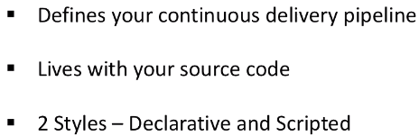

**Declarative:** came 1st, and closer to groovy programming language, which is commonly used in Jenkins echo system.

We focus on Declarative, which is common like CM like Chef, ansible.

We are finding state of pipeline, and its executed within Jenkins based upon state status declared.

**Scripted:** like bash script.

**Declarative Ex: Pipeline have 3 stages of SDLC**

;ml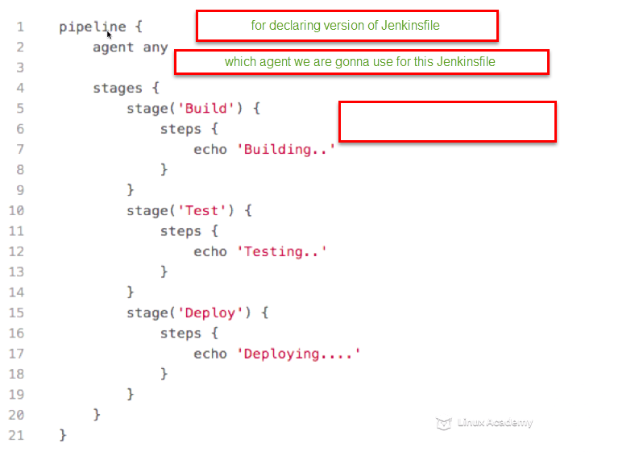

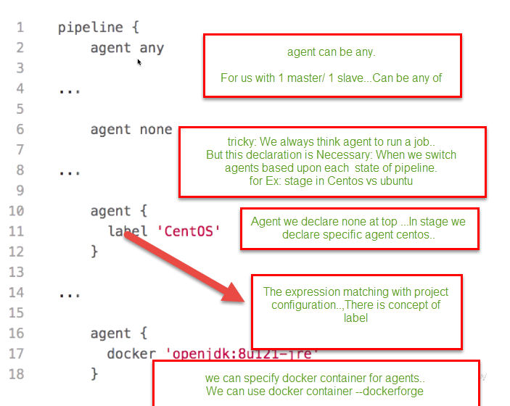

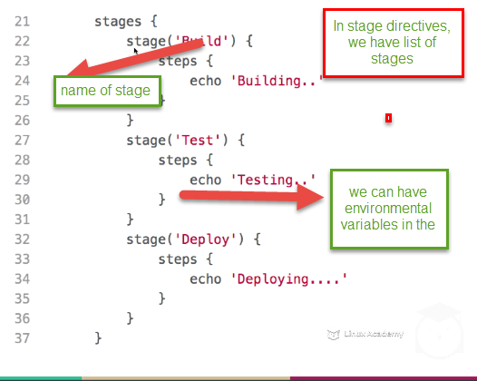

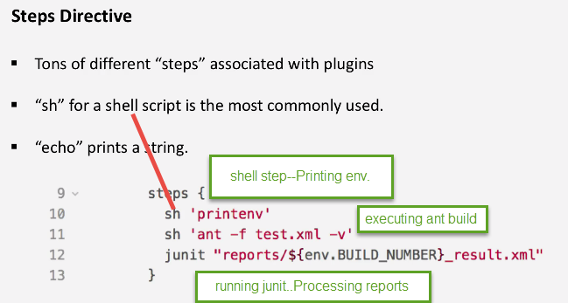

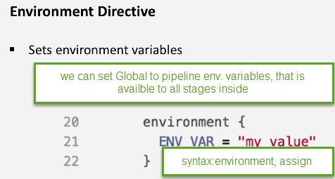

**-----------------------------------_________________----------------------------------_____________**

**Configuring and Running a Pipeline**

We know of docker, configured it…know about jenkinsfile

1. Now let’s configure 1st pipeline. Most of work is done in Jenkinsfile

**Install Groovy package for syntax highlighting**

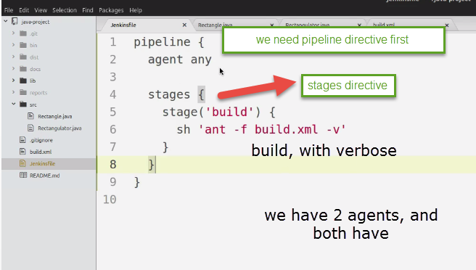

That’s all we need to do on Jenkinsfile to get our jar file built.

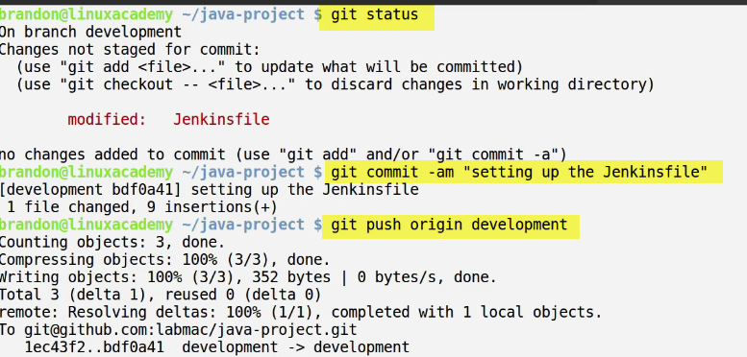

1. Now we need to add git-hook functionality for this pipeline

Browser->github->settings->Integration & services

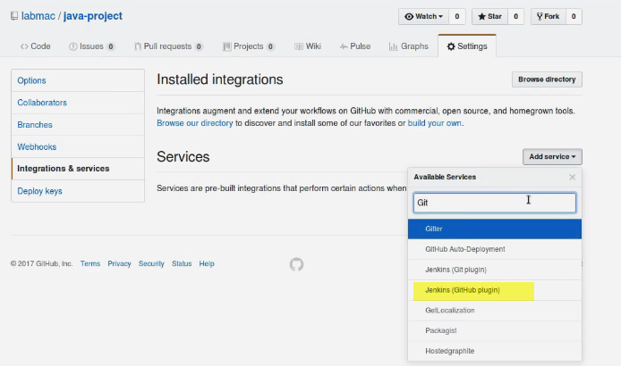

Enter passwd for github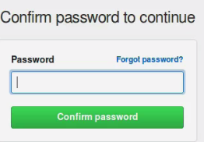

Add web hook url

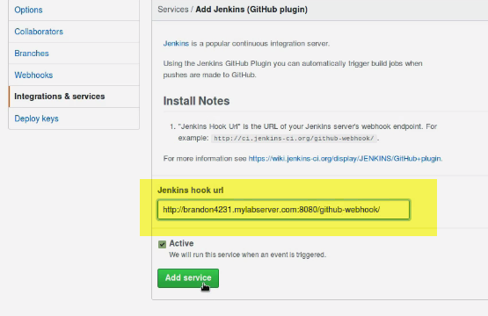

1. Login to Jenkins.., login as admin

New free style project

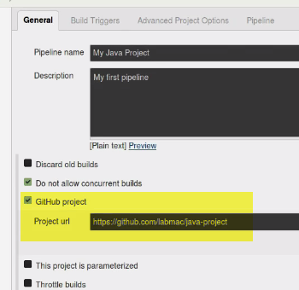

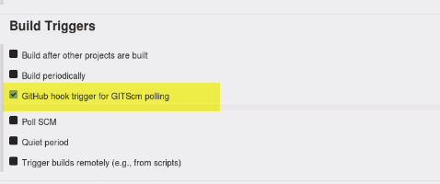

We can also define pipeline, inline in your project configuration.

But we are bnot gonna do that..We are selcting pipeline from SCM

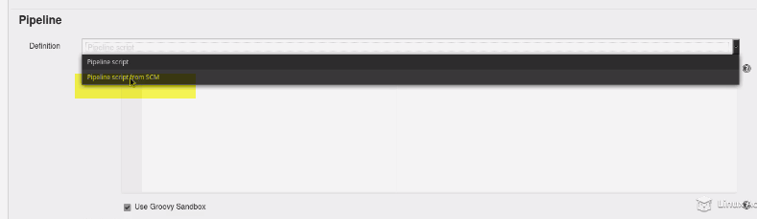

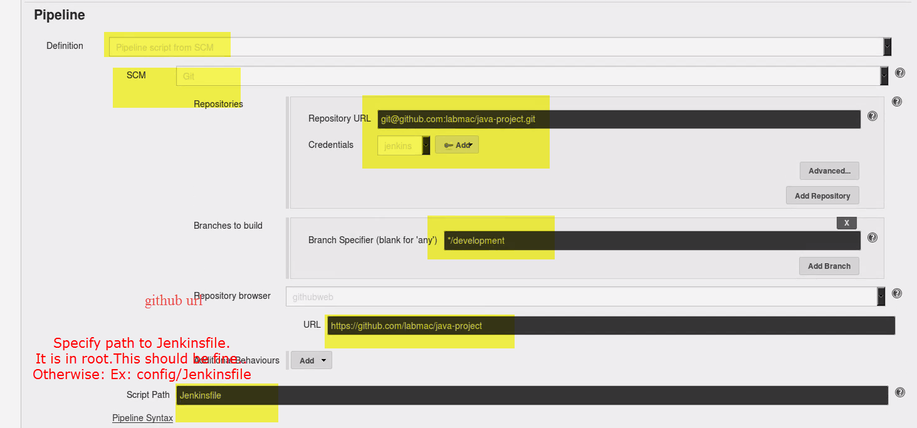

1. Build now
2. Issue:

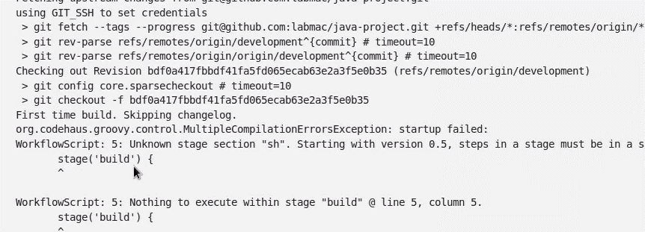

**Console Output: Syntax error, around line:5**

Added Steps , as we forgot to put one of directive

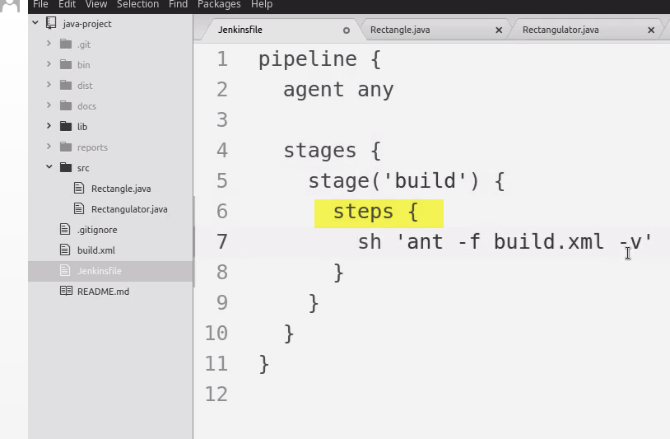

1. Made change. So commit it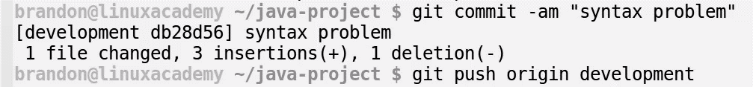
2. Build Success:We can see

Clean,makedir

Javac Compile

Jar files created ETC..

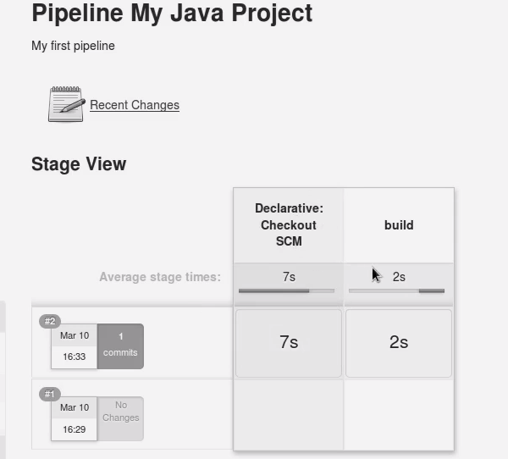

**(STAGE VIEW)**Checkout SCM first, and then

Build step

We can go for more columns, as we go forward

**-----------------------------------_________________----------------------------------_____________**

**Artifacts and Fingerprints**

We are gonna do config in Jenkinsfile.

We want to add an artifact. Make a jar file that will build an artifact.

An artifact can be anything produced from Jenkins build.It’s something that we need to keep when troubleshooting or consume in other project.

To start with, we need add another directive after stages. Called post

Post takes place of traditional project/free style prj for instance.

**Post here corresponds to post-build step.**

**What we gonna do?**

**We will setup another directive, called always (no matter what happens in build step here, or any stage prioir, we will archieve jar file**

**We need global pattern to match that archieve file**

**Archieve anything in dist dir, that matches .jar pattern**

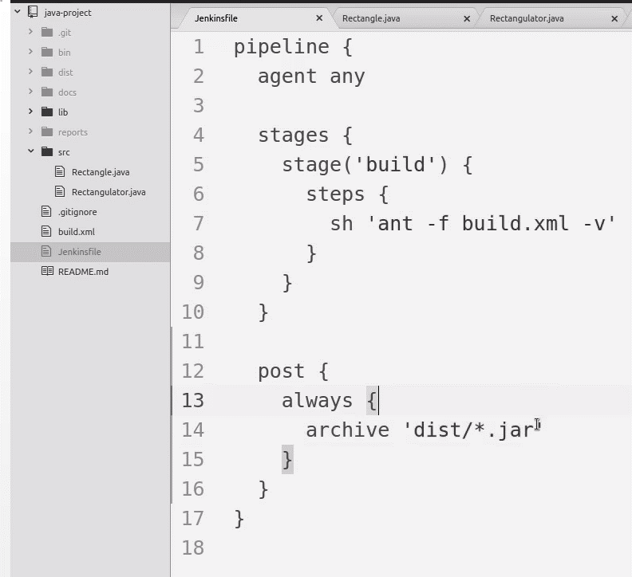

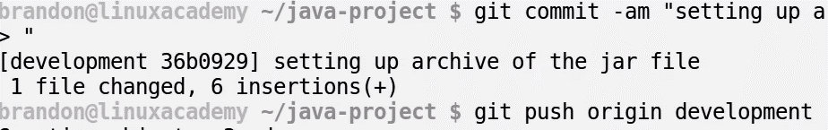

1. Login to jenkins ---build.

**-----------------------------------_________________----------------------------------_____________**

**Notifications**

**Go to jenkins configuration (Manage Jenkins) and setup SMTP server.**

**There are 2 options:**

1. **E-mail notification..Same functionality as 2, but not many options**
2. **Extended E-mail notification**

**1.) Manage Jenkins-> Configure system-> Extended E-mail notification.**

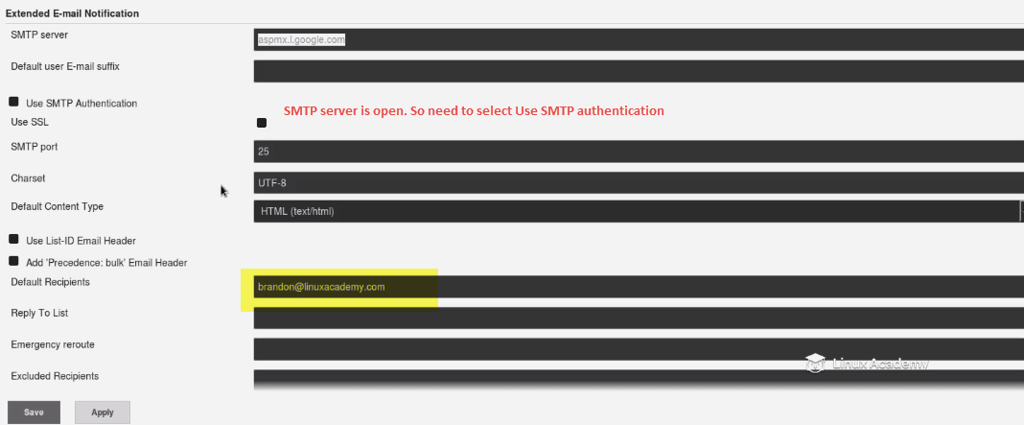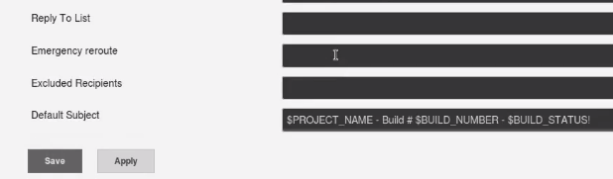

**2.)Manage Jenkins-> Configure system-> Jenkins location-> System Admin email address**

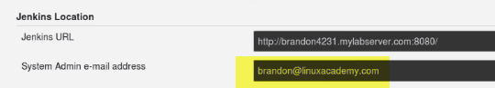

1. **We need to get notifications on**
2. **Failures for sure**

**-----------------------------------_________________----------------------------------_____________**

**The Jenkins CLI**

-perform admin taks

-queries on env.

-info. About config,jobs etc

-shutdown/restart

Preferred way for alternative way to Jenkins dashboard.

1. Generate public key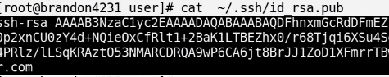
2. Manage Jenkins-> Manage Users-> Gear(next to user a/c)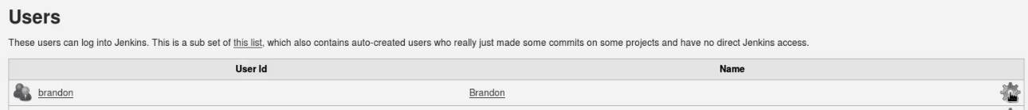

(Or) **localhost:8080/me/configure**

Add SSH keys

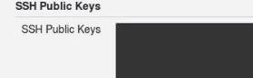

Now I have public associated with admin account.

1. **Download client**
2. Set Jenkins_url env.



1. Set alias for Jenkins URL
2. **Note:**
3. 

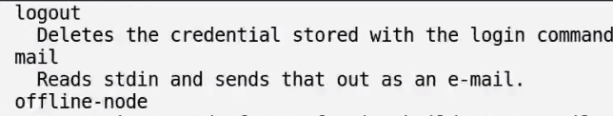

Ex:1 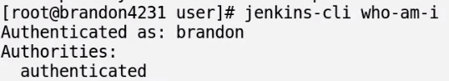

Ex:2 Trigger build from Jenkins CLI:

Jenkins-cli build ‘name of build’

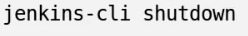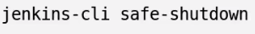

Wait for any jobs to finish before shutdown



**Jenkins-cli safe-restart**

**Install plugin:**



**Return calls allowed from build--Console output of build number**

**-----------------------------------_________________----------------------------------_____________**

**The Jenkins REST API**

REST API: interface over http

We are making http calls to Jenkisn master, and some functionality is happening within Jenkins/ or returing something info. about Jenkins setup.

**-----------------------------------_________________----------------------------------_____________**

**Setting Up a Jenkins Master with Docker**

Install Dokcer containerarized Jenkins master(have Jenkins master running from inside docker container)

1. Add docker repo



1. Yum clean all
2. install docker 



1. Pull Jenkins **image:tag**



1. Now, we have image. Now we want to make a Jenkins dir for Jenkins Container to share on host.

Make a dir Jenkins_home

1. Now, run container

Detached mode in background with root user and ports 8080,50,000

v-> mapping jenins_home within container

1. Goto browser

IPofhost:8080

Now we have Jenkins master running from inside docker container

**-----------------------------------_________________----------------------------------_____________**

Next Steps

Go for Certificate

Practice test

Note Cards

Study guide

Refresh videos/others

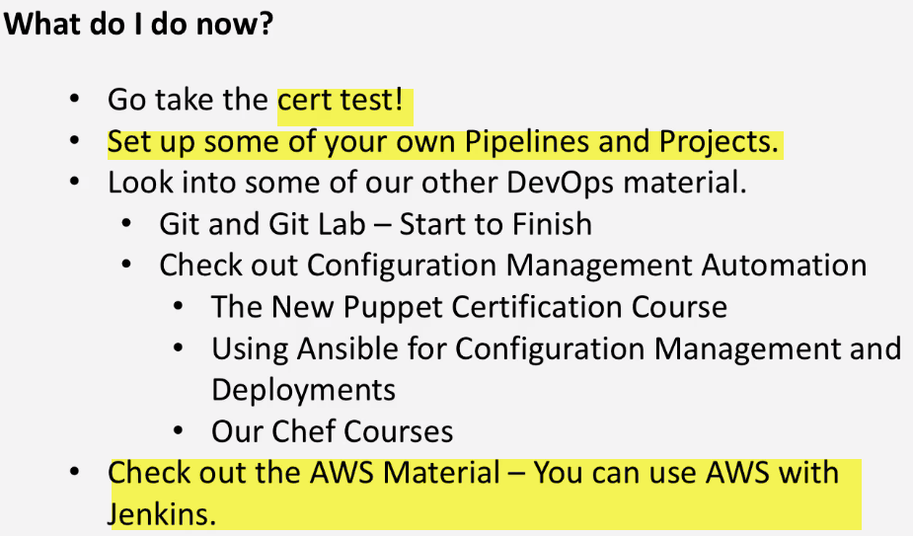

**Installation and Configuration**

|  |
| --- |
| <https://wiki.jenkins-ci.org/display/JENKINS/Installing+Jenkins+on+Red+Hat+distributions> or <http://pkg.jenkins-ci.org/redhat/>  sudo wget -O /etc/yum.repos.d/jenkins.repo <http://pkg.jenkins-ci.org/redhat/jenkins.repo>  sudo rpm --import http://pkg.jenkins-ci.org/redhat/jenkins-ci.org.key  yum update  sudo yum install jenkins  yum install java-1.8.0-openjdk  ifconfig eth0 | grep inet | awk '{ print $2 }' |

1. Setup Jenkins repo, to Get latest pkgs or version of Jenkins available from repo..



1. **Import key associated with repo, so that it is secure.**



1. **Pkg caches are uptodate , and include latest Jenkins repo information we imported.**



1. **Install Jenkins** Yum install Jenkins
2. **Jenkins depends on java openjdk 1.7/1.8 is fine enough..**

Firewall:

systemctl status firewalld

systemctl status iptables

cat /etc/sysconfig/selinux ---disabled---reboot

getenforce

set enforce 0

Service:

chkconfig Jenkins on --- systemctl enable Jenkins

service Jenkins restart systemctl start Jenkins systemctl status Jenkins

/etc/init.d/nginx restart

yum install telnet 🡪 to show u,



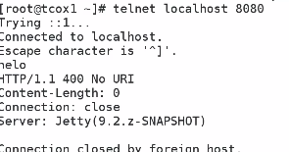

ps aux | grep Jenkins

telnet localhost 8080 🡪 we get response from Jenkins

If we have environment with port restriction, we can’t get response from port 8080

Sol: install nginx as workaround

**Nginx is web-server, which provide core functionality easy to configure, and**

**primary function to use is: proxy connection for 8080.. SO that it will just work on port 80, and access externally.**

1. sudo yum install epel-release --VIMP

sudo yum install nginx

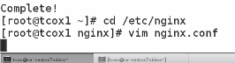

**This is default one, which is listening to port 80 …which is what we wanted..**

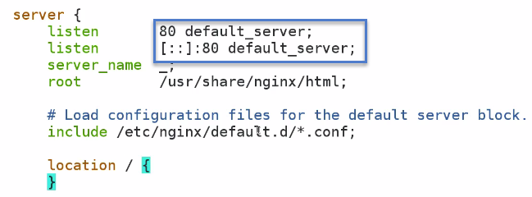

**Proxy_pass: Any connection for http:// forward to 127.0.0.1 on port 80**

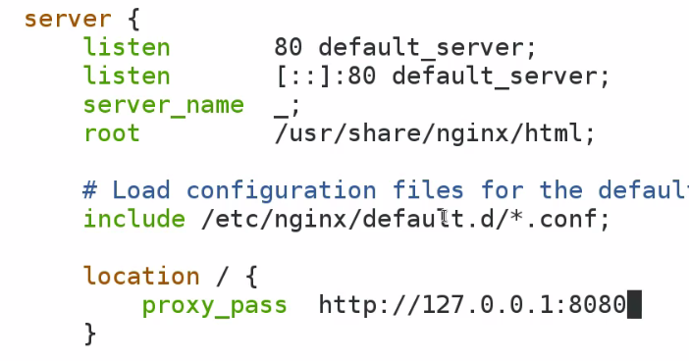

**Issue:**

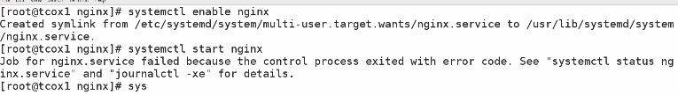**Sol:** 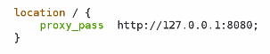

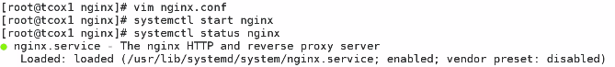



**Elinks🡪local text based browser**

**6.)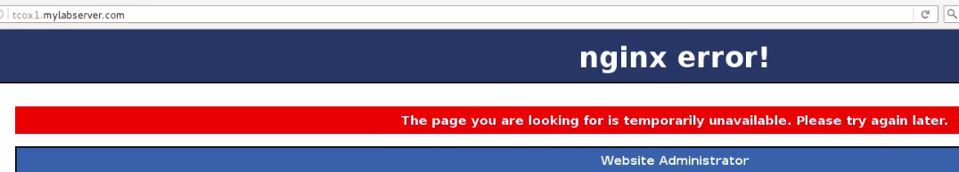We have issue with selinux.**

**6.) Selinux is restricting Port 8080 on backend, is getting blocked for external conection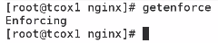Selinux running**

**setenforce**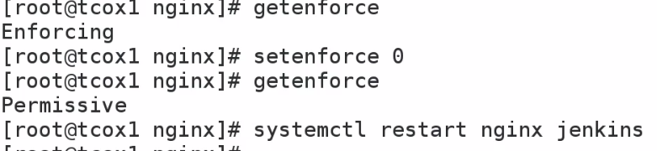

**We can know type of policy for http_port connection **

**Install selinux tools..Use: I don’t want to leave firewall in permissive mode/ disable it completely.**

**(don’t want to leave in less secure).**

**Now, going to add port 80 in http_port ---selinux policies**



**http_ports allowed**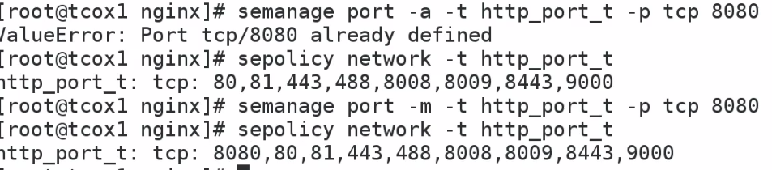

**Added 8080**

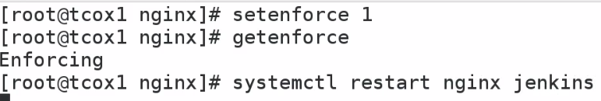

**7.)**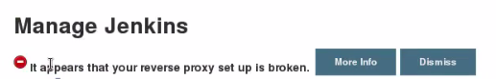

**More info🡪 running behind**

**Copy everything after proxy_pass**

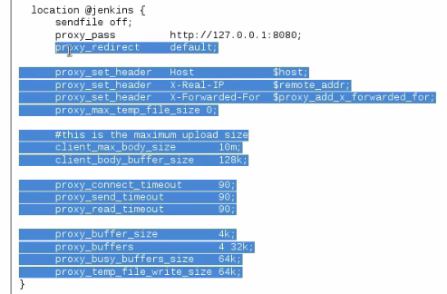



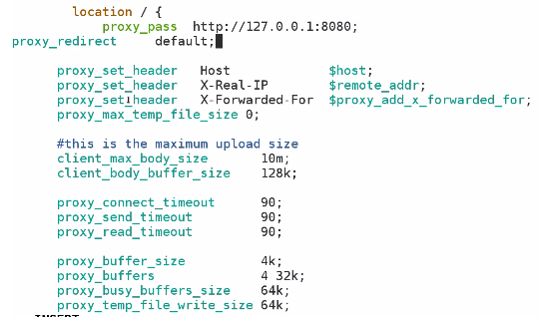

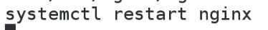

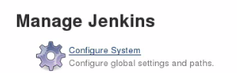

**We have setup ngnix as a proxy, so that we connect to port 80. We grab correct configuration for Jenkins to be a proxy for nginx.. So that we don’t get any error**

1. Issue: New installation of Jenkins Enterprise reports jenkins dead but pid file exists

<https://support.cloudbees.com/hc/en-us/articles/204079674-New-installation-of-Jenkins-Enterprise-reports-jenkins-dead-but-pid-file-exists>

Sol: permission issue.Start as root..provide permission to dir

vim /etc/init.d/Jenkins ---vImp path

1. The following helped me:

some time there will be stale some jenkins processes, so ps -ef | grep jenkins kill all of them and restart as above it will be clean.

ps -ef | grep jenkins

sudo kill -kill <pid>

1. yum install java-1.8.0-openjdk

----------------------------------------------------------------------------

Preparing Our Environment - Build Accounts

When we run jobs/process , it will run with Jenkins userid by default. It is too restricted, and doesn’t allow to do more things



Home dir-> /var/lib/Jenkins looks fine

/bin/false🡪 no shell/login or non-interactive user.

We are not going to use Jenkins command line, but we do want to use Jenkins to generate login shell if needed.

Fix: Change to /bin/bash in /etc/passwd

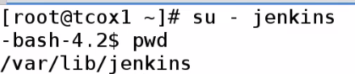

I’m going to run all build using Jenkins user, which is non-privileged user by default.

1. Fix: Generate ssh keys.

This is particularly needed, when I need to login to slave nodes/ build servers.. I need a userId used for this purpose.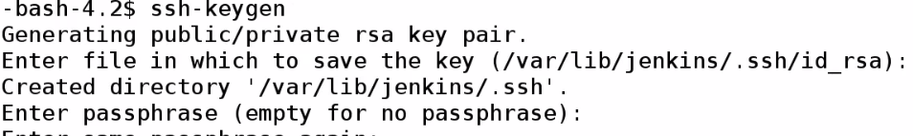

All defaults..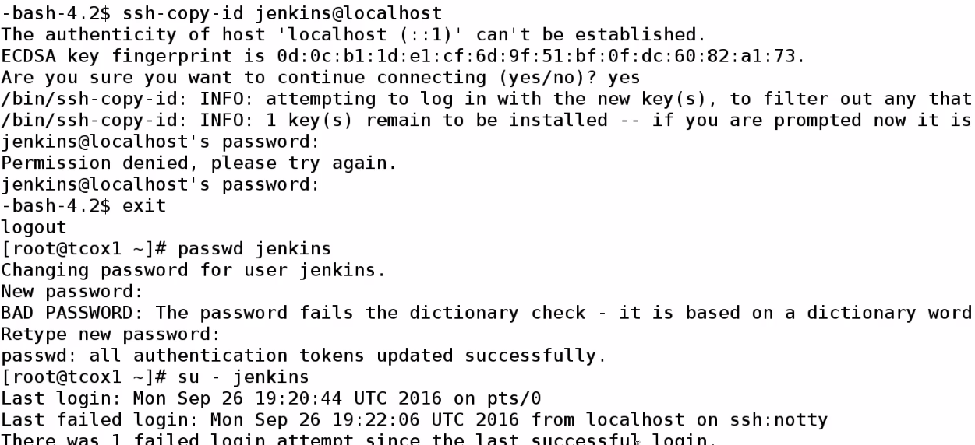

Issue: because password not set for user Jenkins.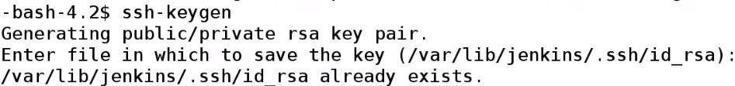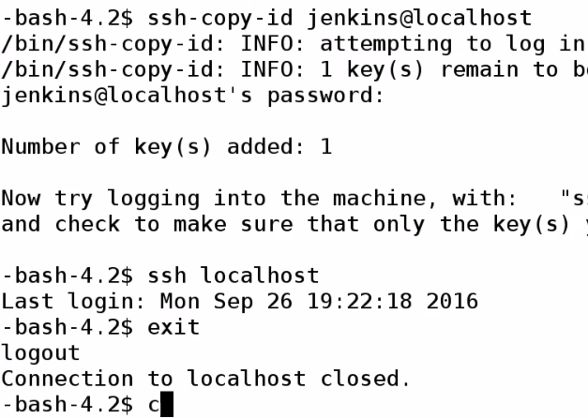

Now, we can login without password…We are going to do for remote user as well

1. visudo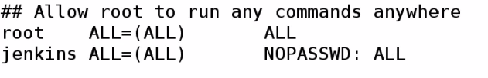

This is needed, if we want jenkins to be Nopasswd user.

This helps to run Jenkins build.., without worrying about passwords or someone knowing, what password iss.

How u secure your environment is up to u..

Best practice: Jenkins user as privileged user.., but it still require password..

In this, we are setting up with minimal 1 build slave.., so we can execute commands without worrying about passwords.

We did all this on 1st server ---Jenkins Master

1. On 2nd server (remote) ---Jenkins slave.

We don’t need to install jnekins. All need to do is:

Add Jenkins user, and give password that should match primary one, but not necessary have to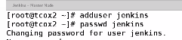

Also, visudo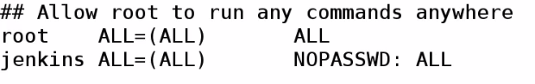

This is because, when we run build on Jenkins slave/node.., Jenkins user have authentication necessary and we control that from master server.

When we create build.., indicates it should run with sudo privileges or not..

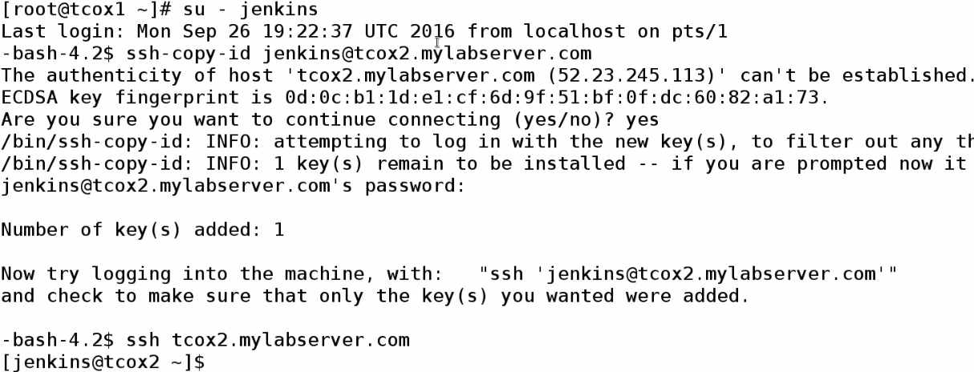

This gives access to 2nd server without any password..

We want to create build by using Jenkins user, on master and slave nodes…So we created Jenkins user on each of these

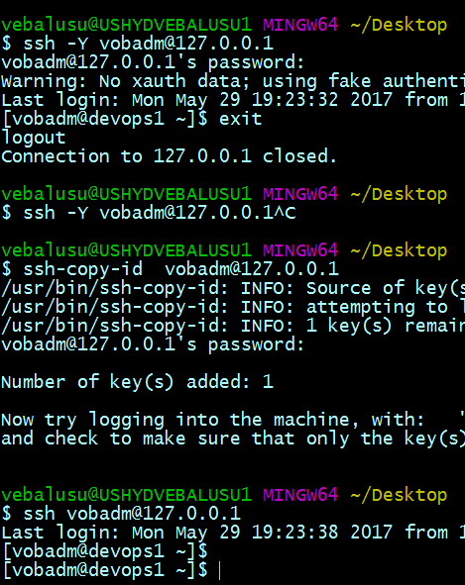

We want to jenkins user to be able to run commands without executing sudo on master/slaves nodes…

So we created Jenkins user on slave nodes.. Enabled login on master node.., created key , exchanged with both ourselves.

If we do build on master node itself, we will do using ssh and build scripts..,for which we may need to generate login shell.. So we need a user tjat has ability to generate login shell which Jenkins userId doesn’t do by default ( we set it up now).

Now, Jenkins can be used as a login user

* Provide sudo rights to execute commands without password.
* Now, we have master node, where Jenkins installed.

Slave nodes, where we are going to build against..

**We are executing builds directly from master to other systems**

----------------------------------------------------------------------------

Our First Jenkins Build

We have setup system, and prepared our system for running commands as Jenkins user on local/remote node..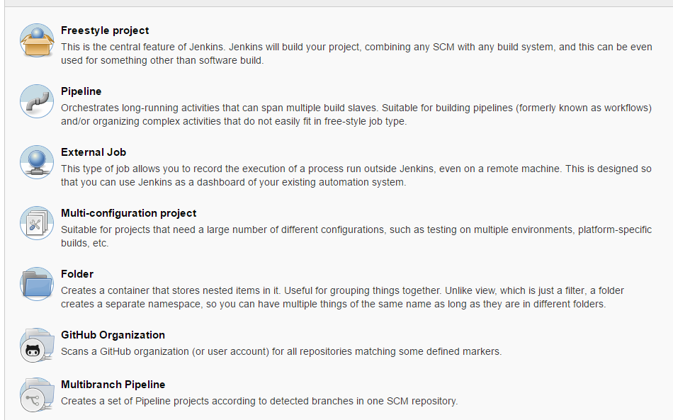

Install Plugins, which gives access to different types of project items

Building: 1.) Click on prj name name🡪 build now

|  |  |
| --- | --- |
|  |  |

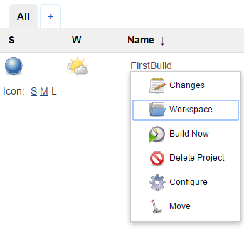

2.) Project-> down scroll (build now)

3.) Build Schedule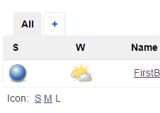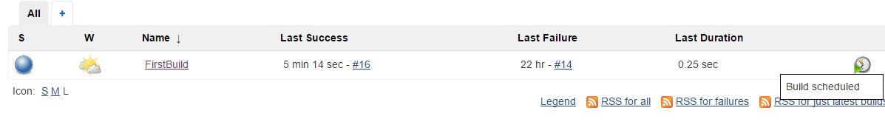

Build status:

2.)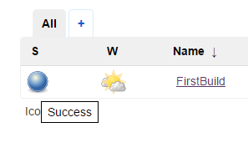

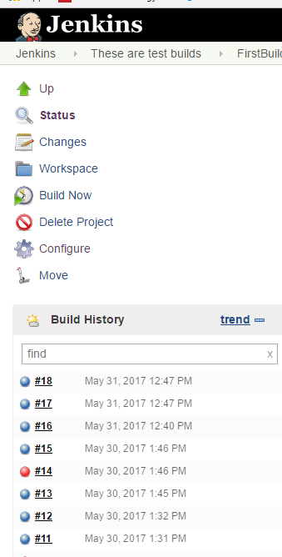

3.) Build history

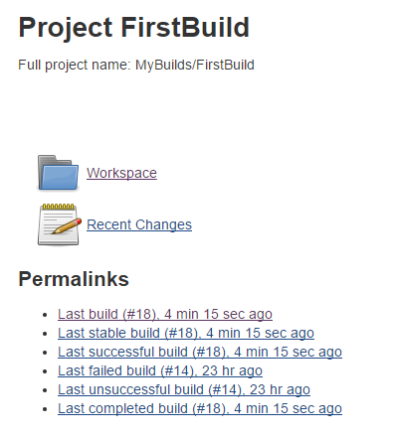

2.)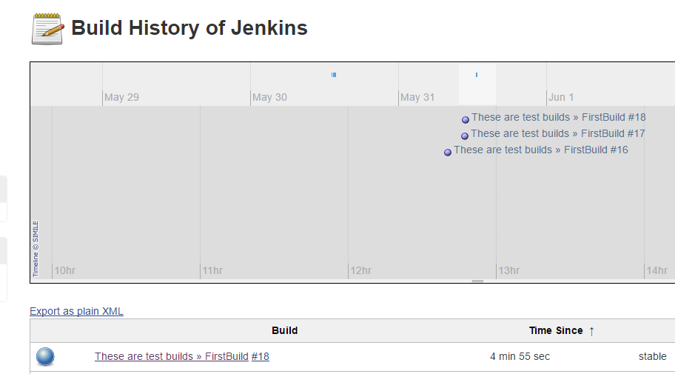

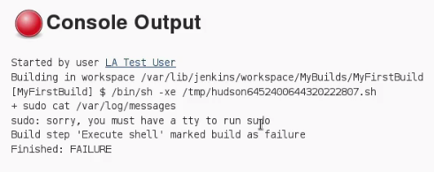

**Issue:** because we are running in back ground, there is no terminal to display output to..\

Sol: %jenkins ALL=(ALL) NOPASSWD: ALL

----------------------------------------------------------------------------

**Plugin Management and Builds**

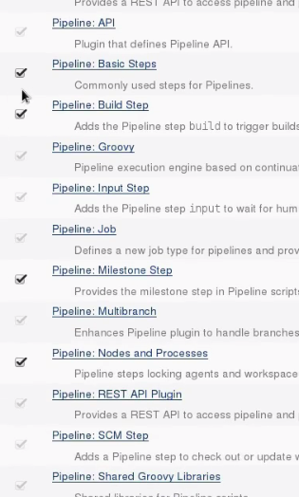

We can see some plugins are greyed out…Are dependencies.

For pipleline, greyedout ones depends on pipeline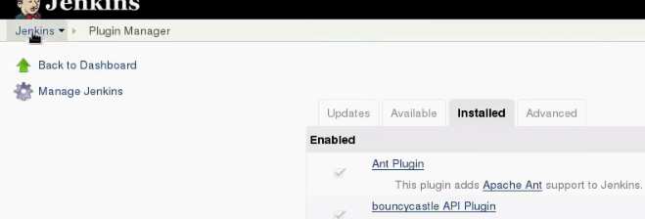

Verify this🡪 This will be in Manage Jenkins-> Manage Plugins🡪 Installed-> SSH Plugin

Configure plugins to be used. 2 ways

1. Manage Jenkins-> Configure system (mostly)
2. Manage Jenkins-> global tool configuration

**Build based on REMOTE SSH**



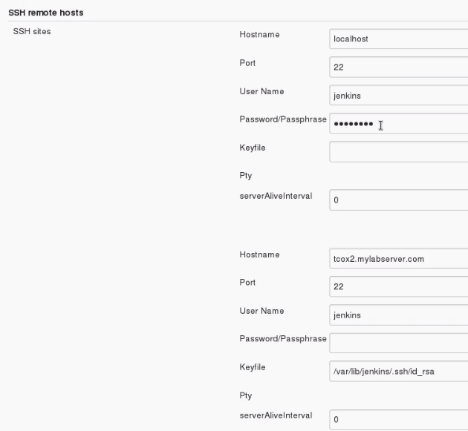

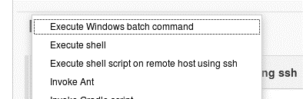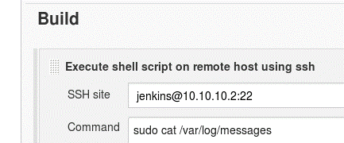

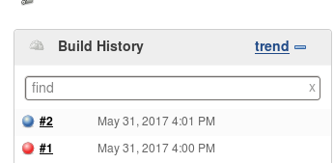

Now, we get build is successful..

We connected remote using SSH plugin, using keys.

**FROM GITHUB**

To indicate it is git respository

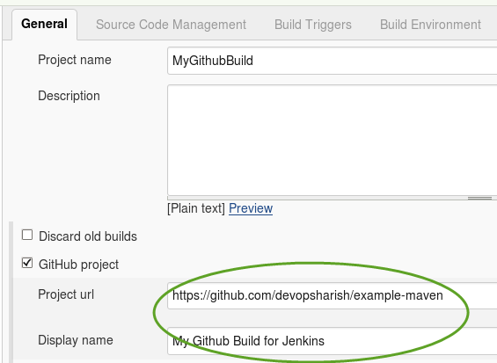

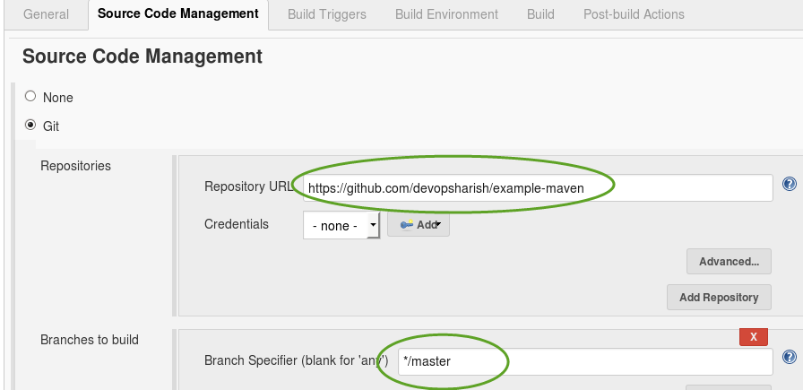

No need of password.., because it is public repository

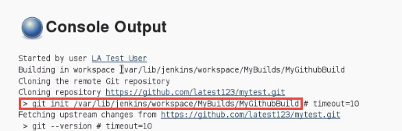

By default, github plugin will build in wks it is created.

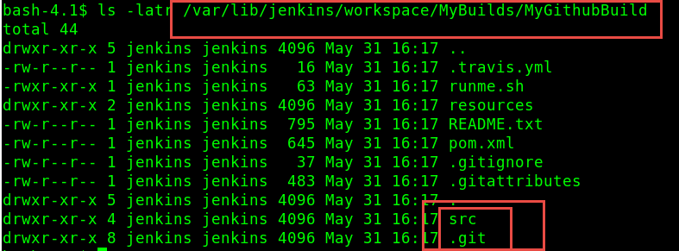

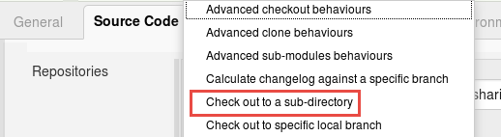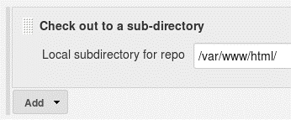

**ISSUE:**

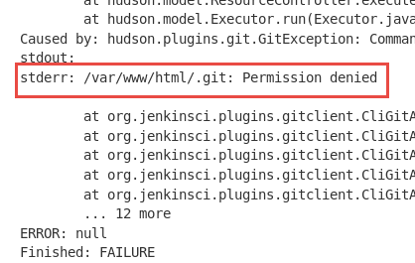

**Sol: **

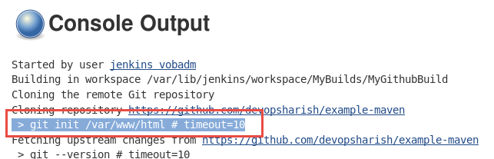

----------------------------------------------------------------------------

**Creating Scheduled Builds**

Most of time, when we create a build in Jenkins—It’s gonny run periodically-🡪 2 ways

1. Buitin—corn like entry
2. Plugin

Manage Jenkins-> manage plugins-> available🡪 **schedule build plugin**

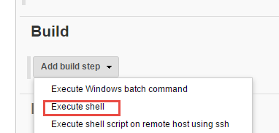

After saving project.., bcz of plugin

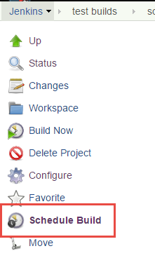

**Build triggers**

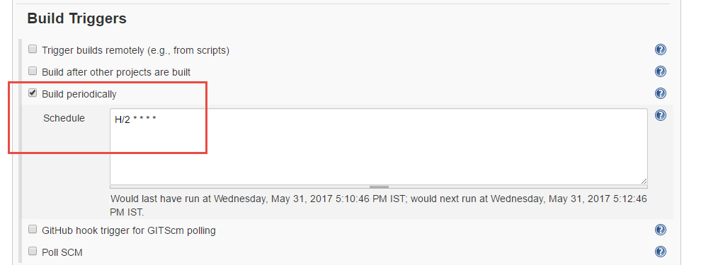

**Build periodically: Build every 2 min**

----------------------------------------------------------------------------

**Setting up a Slave node**

Jenkins master is only server, Jenkins actually installed. It can offload jobs to slave node.

Slave node is setup in our Jenkins configuration in Jenkins. Once it’s been proper setup info, will deploy Jenkins-agent, which allows to control that agent using ssh, using credentials we setup.

**If we haven’t defined slave node:**

1. **Create Jenkins user on slave node**
2. **Exchange username ssh credentials/keys, so that we can use them to login from master to slave.**

**If we need plugins to use external utilities, we should install them.**

**Ex: 1.) git on slave node**

**If slave node is called upon build, that requires git..bcz we configured github plugin**

1. **Java is required for agent to deploy. Fortunately, as long as**

**Determine how master uses slave**

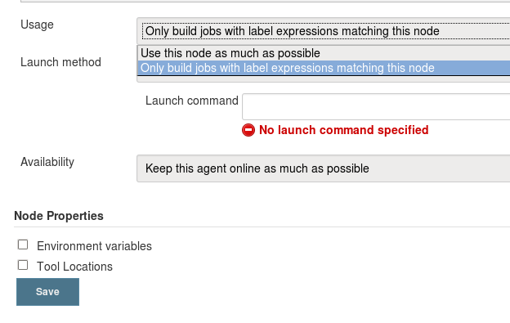

**Launching method**

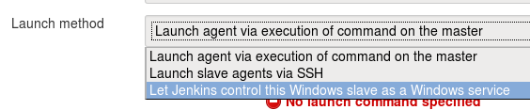

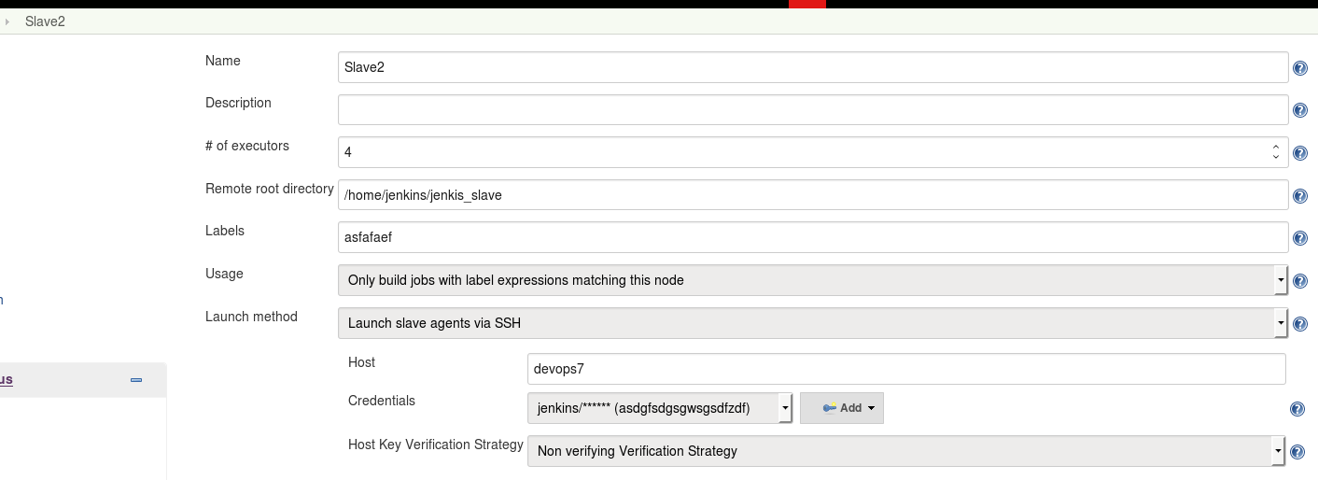

**Launching Jobs on the Slave Node**

To force Jenkins master to offload build to slave.., We have to restrict where ever this project can be run because it have to pass label where we have setup build slave.

Only builds that called label, talking about can run on build slave..

Typically master will control based upon what ever conditions mentioned.., including the executors on master server are doing busy doing other things. But there is build slave with executors Open ..It will Offload build to One of its slave..

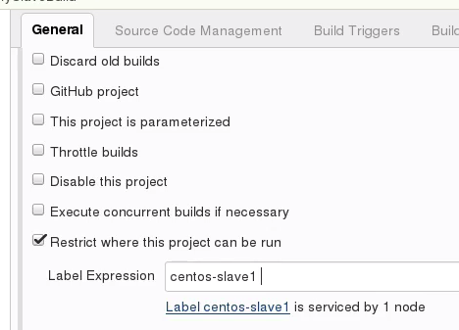

In this, We are mentioning build to run on slave Centos..

If we have have multiple slaves.., And we have indicated label called centos for example.., We will see list we have available for us.